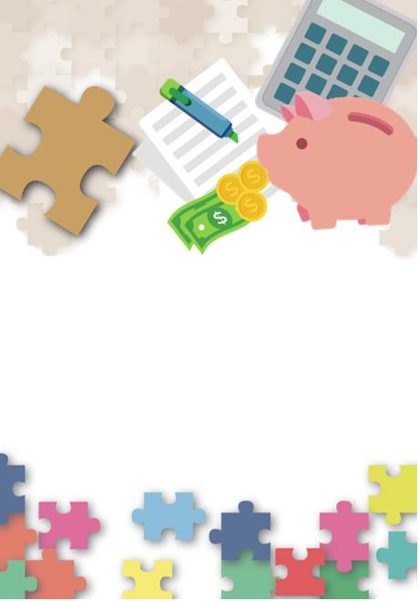
Citizenship, Economics and Society
(Secondary 1-3)
Support Resources
Secondary 1

Module 1.3:
Financial Education
Personal, Social and Humanities Education Section
Curriculum Development Institute
Education Bureau
Introduction

- The “Citizenship, Economics and Society (Secondary1-3) Support Resources” covers the essential learning contents of Strands 1, 5 and 6 in the Personal, Social and Humanities Education Key Learning Area. It is designed to support the implementation of the Citizenship, Economics and Society curriculum.
- The support resources provide diversified learning activities to help students acquire knowledge and understand concepts, develop skills and nurture positive values and attitudes. In addition, they offer teaching guidelines and suggestions on learning and teaching activities for teachers’ reference. Further, they provide reading materials to enhance students’ interest in reading.
- “Module 1.3: Financial Education” for Secondary 1 was developed by the Personal, Social and Humanities Education Section, Curriculum Development Institute of the Education Bureau.
Module 1.3: Financial Education

Contents

 | Page
Introduction | 4
Teaching Design
Lesson 1 to Lesson 6: Making decisions about spending money | 6
Lesson 7 and Lesson 8: Online shopping | 18
Lesson 9 and Lesson 10: Green consumption | 22
Learning and Teaching Activities
Worksheet 1: Different uses of money | 25
Worksheet 2: Money management skills: How to do budgeting? | 30
Worksheet 3: Financial needs at different life stages | 33
Worksheet 4: Unveiling the interest rate of credit card cash advance | 43
Worksheet 5: Well spent or not? | 47
Worksheet 6: Services provided by financial institutions | 51
Worksheet 7: Many a little makes a mickle! | 55
Worksheet 8: Be cautious when shopping online | 71
Worksheet 9: What are intellectual property rights? | 77
Worksheet 10: What are your considerations when shopping? | 82
Worksheet 11: Do you practise green consumption? | 85
Self-learning Materials
- Learn from celebrities | 90
- Intellectual property rights protection | 91
- Carbon emissions and Hong Kong | 92
References | 94
Introduction

The focus of financial education is to cultivate students’ financial literacy, helping them acquire the right financial management knowledge, methods and skills and develop proper values and attitudes towards money and financial management. From different subjects at primary level (e.g. General Studies, Mathematics) and through cross-curricular mode (e.g. class teacher periods, values education activities, etc.), students have learned how to manage money. Related learning contents from General Studies include “to know the ways of making sensible consumer decisions” (e.g. understanding consumer rights and responsibilities, factors affecting choices of goods/services), “managing and using money” (e.g. planning how to make good use of one’s money, making good use of money: use of red packet money and Octopus Card) and “making good use of resources and practising green living” (e.g. waste reduction at source, saving energy). Together with the knowledge and skills from different topics in Mathematics, students are able to apply flexibly the knowledge and skills of financial management to daily life situations. For example, when students learn the topic “to know the ways of making sensible consumer decisions” in General Studies, they can apply the learning contents in the topics “currency” and “four arithmetic operations” in Mathematics to preliminarily identify the differences between “needs” and “wants” as well as cultivate a proper attitude towards consumption through shopping activities. Another example is that when learning the topic “pie charts” in Mathematics, students are able to connect to the learning contents in the topic “managing and using money” in General Studies, and show how to allocate the use of pocket money through drawing pie charts, plan their spending and saving, as well as set up saving goals and cultivate a good habit of saving. Knowledge, skills, values and attitudes that students have acquired at primary level provide the foundation for their further study of financial management at junior secondary level.

Apart from learning how to make informed, rational and responsible decisions on money management and act accordingly, students also need to understand the responsibilities, costs and risks of borrowing. Although students do not need to borrow at junior secondary level, they still have to understand at this stage that they need to give careful consideration (including critically evaluate one’s financial situation and ability of repayment, and read borrowing terms carefully and calculate the interest payment on a loan) if they need to borrow in the future for achieving goals in different life stages (e.g. pursuing further studies, purchasing a property). At the same time, students should understand the importance of saving and cultivate the habit of saving. They will also have a preliminary understanding of general financial services provided by banks and other financial institutions (e.g. deposits, insurance, loan services, investment, etc.) so as to establish the concept of wealth accumulation and get prepared for making use of savings to invest in the future. They also need to understand that investment involves risks and they should not believe in the claim of “low risk, high return” investments to avoid investment scams. Besides, students should understand that they must earn money in a legal and proper way as well as be cautious of offers to make easy money. Last but not the least, students should understand that money not only can meet one’s own consumption needs but it can also help people in need. This helps students develop a caring attitude towards others.

Students will learn precautions about online shopping. With increasing popularity of the Internet, online shopping has become a trend. While enjoying the convenience brought by online shopping, students should also be aware of various potential risks and traps involved in online consumption and enhance the awareness of cyber security to avoid being cheated. While shopping online and conducting online transactions, apart from observing legal requirements and exercising self-discipline and self-control, students should pay extra attention to the protection of personal data and respect intellectual property rights. They need to enhance the awareness of potential cyber infrastructure security risks and threats such as cyber crimes. Besides, they need to avoid bearing debts due to overspending.

Apart from learning how to spend money rationally and responsibly from an individual perspective, students will learn, from a social perspective, how to reduce waste, protect the environment and conserve resources of the earth by practising green consumption. Through encouraging students to practise green consumption, their environmental awareness and civic responsibilities can be fostered.

Suggested Number of Lessons
- 10 lessons (40 minutes each)

Teaching Design:
Topic: | Financial Education
Duration: | 10 lessons
Learning Objectives: | - know the different uses of money and make informed, rational and responsible money management decisions and act accordingly;  - understand the importance of saving and cultivate the habit of saving;  - understand that one needs to bear responsibilities, cost and risks when borrowing;  - understand the importance of prudent financial management and the need to give careful consideration before borrowing;  - recognise general financial services provided by banks and other financial institutions;  - establish the concept of wealth accumulation, and understand that investment involves risks and the need to balance risks and returns when making an investment;  - understand that one has to earn money in a legal and proper way and be aware of claims of ways to make easy money;  - understand and be aware of the potential risks and traps of online shopping, and enhance the awareness of cyber security;  - practise green consumption in daily life so as to help reduce waste, protect the environment and conserve resources of the earth, and practise green consumption in daily life; and  - develop and cultivate proper values and attitudes towards money and financial management, including rationality, responsibility, care for others, diligence, treasure, etc.
Lesson 1
 |  | Suggested Lesson Time
Enquiry Process: | - Set:  - The teacher briefly introduces the contents of these six lessons and invite students to reflect on and share briefly if they have made any impulse buying in the past three months. | 5 minutes
Enquiry Process: | - Interactive teaching:  - The teacher starts with Worksheet 1 “Different uses of money”, asks students to calculate the amounts of money that Chan Siu Ming allocated for different uses (i.e. consumption, savings and donation) and guides students to think about whether Chan Siu Ming’s financial management habit is appropriate or not.  - The teacher refers to the questions in Activity 1 “Why should you save money?”, helps students reflect on and understand the importance of saving through asking questions, and introduces “saving made easy” to help students understand the concept of “saving before spending”.  - The teacher first discusses Chan Siu Ming’s “saving plan” with students to bring out the “SMART” Saving Principles. The teacher then asks students to browse the website of the Investor and Financial Education Council (IFEC)  (https://www.ifec.org.hk/web/common/images/parent/tools-activities/smart-saving-kit.pdf) to find out and write down the specific content of the “SMART” Saving Principles; and leads the class to discuss how they can apply these principles in daily life. | 20 minutes
Enquiry Process: | - Student reflection and knowledge consolidation:  - The teacher briefly explains the requirements of Worksheet 2 “Money management skills: How to do budgeting?” and asks students to complete it at home.  - The teacher introduces the “Money Tracker – the Chin Family” Mobile Application developed by the IFEC to help students apply what they have learned to record their daily expenses with the mobile applications. Students can review their own financial positions from time to time, which will help them establish good financial management habits for now and for the future. The teacher can also encourage students to complete the extended learning activity “Money Tracker” by themselves to understand their own consumption habits and make better budgets and plans.  - The teacher concludes by offering some financial management tips, for example, list items of income and expenditure; set a saving plan and establish the practice of “saving before consumption”; distinguish between “needs” and “wants”; refer to the “SMART” principles and set a saving goal. | 10 minutes
Homework: | Students complete Worksheet 2 “Money management skills: How to do budgeting?” at home to understand their own consumption habits and make better budgets and plans.
Extended Learning Activity: | Students participate in the extended learning activity “Money Tracker” to use the “Money Tracker – the Chin Family” Mobile Application developed by the IFEC or other methods to persistently record their personal expenses and start to develop good financial management habits.
Learning and Teaching Resources: | Worksheets 1 and 2; “Money Tracker – the Chin Family” Mobile Application

Lesson 2
 |  | Suggested Lesson Time
Enquiry Process: | - Set:  - Peer learning: The teacher invites students to share their answers in Worksheet 2 “Money management skills: How to do budgeting?” and tell why they would allocate their pocket money that way and guide them to review their own consumption patterns.  - The teacher invites students to briefly share their short-term financial management goals, and explains to them that this lesson will discuss about how to meet the financial needs in different life stages. | 10 minutes
Enquiry Process: | - Interactive teaching:  - Direct instruction: The teacher asks students to analyse Chan Tai Ming’s consumption and wedding budgets and then think about how they can help Chan Tai Ming implement his wedding plan* and answer the questions in Activity 1 “Give Tai Ming a hand”  * Some items that students may not be familiar with are included in Chan Tai Ming’s monthly personal budget (e.g., “repayment of student loan”, “insurance”, “reserved for tax” and “investment”). The teacher may decide if there is a need to go into detail about each item based on the interest, ability and prior knowledge of students. Appendix 1 “Basic knowledge about insurance” covers the types and functions of insurance for students’ reference.  - Group discussion and presentation: Students discuss in pairs or groups of four. The teacher invites some groups to present their discussion results.  - Summary: The teacher summarises different ways to achieve financial management goals and helps students understand how they can realise the goals or meet unexpected needs in different life stages. | 20 minutes
Enquiry Process: | - Extended learning:  - Direct instruction: The teacher makes use of Appendix 2 “Know more: Consumption vs. borrowing” to briefly introduce relevant knowledge about credit card, including the information on a credit card statement and the five top tips on using credit cards. The teacher also emphasises that shopping with credit cards is a form of borrowing and the outstanding amount will incur expensive interest. The teacher reminds students that they will have to repay the money borrowed and they should not “spend future money”*.  * Based on students’ interest, ability and prior knowledge, the teacher may explore the concept of bankruptcy and its consequences and costs with students, and encourages students to read Appendix 3 “Know more: Overspending may lead to bankruptcy” and visit the website of the “Investor and Financial Education Council” (IFEC) to learn related knowledge.  - The teacher asks students to read and complete Self-learning Material 1 “Learn from celebrities” by themselves, which will help cultivate their positive values and attitudes. | 10 minutes
Homework: | Students read Self-learning material 1 “Learn from celebrities” by themselves.
Learning and Teaching Resources: | Worksheets 2-3; Appendices 1 to 3; Self-learning Material 1

Lesson 3
 |  | Suggested Lesson Time
Enquiry Process: | - Set:  - The teacher asks students “Why is there a need for borrowing?” and invites them to share the answers. | 10 minutes
Enquiry Process: | - Interactive teaching:  - Direct instruction: The teacher helps students understand the responsibilities, costs and risks that they must bear if they borrow. Before they decide to borrow, they must first review if they have a genuine need for that sum of expenditure. The teacher then helps students understand that borrowing is not the only option, they may also save before they spend.  - Group discussion: Students work in pairs or groups of four to discuss “Think about it: Why should I borrow?”. The teacher invites some groups to report their discussion results.  - Teacher debriefing and student reflection: The teacher briefly explains what interest is and summarises students’ discussion results on the following questions: “If costs are involved in borrowing, why do people borrow?” and “What are the factors we should consider before borrowing money?”*.  * Based on students’ interest, ability and prior knowledge, the teacher may explain the contents in Appendix 4 “Know more: The difference between payment by credit card and credit card cash advance” to the students. | 20 minutes
Enquiry Process: | - Extended learning:  - The teacher briefly introduces the requirements in Worksheet 4 “Unveiling the interest rate of credit card cash advance” and asks students to preview the worksheet as well as to complete Extended Activity “Compare two different kinds of loan” at home*.  * Regarding the extended learning activity, the teacher may decide on the appropriate contents for extended learning, depending on the lesson time and based on students’ interest, ability and prior knowledge. | 10 minutes
Homework: | Students complete Worksheet 4 “Unveiling the interest rate of credit card cash advance” (including the steps of calculation of compound interest) and Extended Learning Activity “Compare two different kinds of loan”.
Learning and Teaching Resources: | Worksheets 4; Appendix 4; Extended Leaning Activity “Compare two different kinds of loans”.

Lesson 4
 |  | Suggested Lesson Time
Enquiry Process: | - Set:  - The teacher invites students to share their understanding about the interest rate of credit card cash advance acquired from Worksheet 4 “Unveiling the interest rate of credit card cash advance” with the class. | 5 minutes
Enquiry Process: | - Interactive teaching:  - Direct instruction: The teacher discusses Worksheet 4 “Unveiling the interest rate of credit card cash advance” with the students, helps them understand that borrowing with credit cards would usually incur high interest and also the power of “compound interest”.  - The teacher invites students to share their answers in Extended Learning Activity “Compare two different kinds of loans” with the class.  - The teacher checks the answers in Extended Learning Activity “Compare two different kinds of loans” with the students and helps them understand the fundamental differences between the loan from the Tertiary Student Finance Scheme and credit card cash advance. Students learn more about the Tertiary Student Finance Scheme, and understand that the cost of credit card cash advance is high and they should not use it casually.  - Group discussion: The teacher asks students to work in pairs to discuss Questions 1 to 6 in Worksheet 5 “Well spent or not?”. Students’ discussion results will be shared in class in the next lesson. | 25 minutes
Enquiry Process: | - Extended learning:  - The teacher briefly explains the requirements in Worksheet 5 “Well spent or not?” and Worksheet 6 “Services provided by financial institutions” and asks students to complete Question 7 of Worksheet 5 and Worksheet 6 by themselves. | 10 minutes
Homework: | Students complete Question 7 of Worksheet 5 “Well spent or not?” and Worksheet 6 “Services provided by financial institutions”.
Learning and Teaching Resources: | Worksheets 4 to 6; Appendix 5; Extended Learning Activity “Compare two different kinds of loans”

Lesson 5
 |  | Suggested Lesson Time
Enquiry Process: | - Set:  - The teacher invites some groups to share their discussion results of Questions 1 to 6 in Worksheet 5 “Well spent or not?”. | 5 minutes
Enquiry Process: | - Direct instruction:  - The teacher helps students understand the responsibilities, costs and risks that they will have to bear if they borrow, using information from Source 1 “Tertiary Student’s Excessive Consumption Makes Bankruptcy Common” and Source 2 “Lok Yi’s Diary” in Worksheet 5 “Well spent or not?”.  - The teacher invites students to share their answers of Question 7 in Worksheet 5 “Well spent or not?”. The teacher summarises students’ answers and guides them to reflect and review their consumption patterns and behaviours. | 10 minutes
Enquiry Process: | - Interactive teaching:  - Direct instruction: The teacher checks the answers in Worksheet 6 “Services provided by financial institutions” with students and helps them understand the financial services provided by financial institutions. In addition, the teacher asks students if they or their family members have used those financial services and see if they can name some other services provided by banks*.  * The teacher may explain the contents in Appendix 6 “Enrichment: Virtual banks”, based on students’ interest, ability and prior knowledge. | 20 minutes
Enquiry Process: | - Extended learning:  - The teacher asks students to prepare for the next lesson by watching IFEC Animation Series: “The power of compound interest”. | 5 minutes
Learning and Teaching Resources: | Worksheets 5 and 6; Appendix 6

Lesson 6
 |  | Suggested Lesson Time
Enquiry Process: | - Set and revision:  - The teacher briefly reviews Worksheet 4 “Unveiling the interest rate of credit card cash advance” with students and briefly explains the power of the effect of “compound interest” on savings and investment. | 5 minutes
Enquiry Process: | - Interactive teaching:  - Direct instruction: The teacher briefly explains the power of the effect of “compound interest” on savings and investment with Worksheet 7 “Many a little makes a mickle!” and brings out that appropriate investment can help us accumulate wealth and fight inflation. The teacher encourages students to cultivate good saving and/or investment habits early*.  * The teacher may adjust the contents based on the interest, ability and prior knowledge of students. Students may refer to Appendix 7 “Know more: Invest appropriately helps fight inflation” and learn that investment can help fight inflation. For knowledge on investment tools, students may refer to Appendix 8 “Know more: The key difference between shares, bonds and deposits” and Appendix 9 “Hang Seng Index (HSI)”. | 15 minutes
Enquiry Process: | - Conclusion:  - The teacher summarises the importance of investment briefly and cultivates students’ positive values and generosity through reading the contents in Appendix 10 “Know more: The good deed of a good person”.  - The teacher explains the relationship between risks and returns of investment, helps students understand that risks and returns are usually positively correlated, using the IFEC Animation Series: “Risk and Return”, and reminds students that they must think carefully before making any investment* and should not believe the claim of “low risk, high return” investments.  - Through an example of investment fraud shown in a video clip, students are asked to provide suggestions of avoiding the investment traps. They are reminded to be aware of claims of ways to make easy money.  * Depending on the lesson time and students’ interest, ability and prior knowledge, the teacher may ask students to complete Appendix 11 “Know more: Other anti-deception information” and Appendix 12 “Know more: Risks and returns of investment”. Regarding the responsibilities and rights of investors, please refer to Appendix 13 “Know more: Responsibilities and rights of investors”. | 20 minutes
Homework: | Watch “3-minute Concept” Animated Video Clip “Personal Resource Management: Managing Finance” and review the key points learned in the lesson.
Learning and Teaching Resources: | Worksheet 7; Appendices 7 to 13; IFEC Animation Series: “Risk and Return”; “3-minute Concept” Animated Video Clip “Personal Resource Management: Managing Finance”

Lesson 7
Pre-lesson Preparation | Students collect a piece of news on online fraud and watch the video “Security Considerations on Electronic Transactions (I)”.
 |  | Suggested Lesson Time
Enquiry Process: | - Set:  - The teacher briefly explains the potential risks of online shopping with the flow chart of online shopping and the “Cyber Security Information Portal” website in Activity 1 “Potential risks of online shopping” | 10 minutes
Enquiry Process: | - Interactive teaching:  (Note: When teaching this part, teacher should help students understand the importance of proper use of the Internet to the normal operation of society. A normally operated network is closely related to the orderly functioning of society (e.g. online shopping, financial services, etc.). This will enable students to recognize the impacts of improper use of the Internet and cyber crimes on the general public. and enhance their awareness of national security (cyber security).  - Direct instruction: The teacher briefly introduces the current situation of online shopping and the problems that may come up in electronic transactions, using Worksheet 8 “Be cautious when shopping online”.  - Group discussion: Students work in pair to answer Questions 1 to 4 in Worksheet 8 “Be cautious when shopping online”.  - Presentation and class discussion: The teacher invites students to present and share their answers, especially their answers to Question 4. If time permits, the teacher may invite students to share their online shopping experiences. | 15 minutes
Enquiry Process: | - Interactive teaching:  - Referring to the contents in the video “Security Considerations on Electronic Transactions (I)”, the teacher asks students the following questions:  - Which webpages or websites would they visit for online shopping?  - Which payment methods would they use when they shop online? Are there any methods not mentioned in the video?  - Have they paid attention to the relevant risks when they do their daily shopping online?  - The teacher asks students:  - Do you know what two-factor authentication is?  - What are some methods of two-factor authentication?  - Direct instruction: The teacher plays the video “Security Considerations on Electronic Transactions (II)” and explain the security considerations on electronic transactions and the matters to note when conducting other electronic transactions so as to enhance students’ awareness of cyber security. | 15 minutes
Homework: | Students complete Activity 2 “More on online shopping” and visit the website “Cyber Security Information Portal: Save Online Shopping” to consolidate their learning.
Learning and Teaching Resources: | Worksheet 8; videos “Security Considerations on Electronic Transactions (I) and (II)”

Lesson 8
 |  | Suggested Lesson Time
Enquiry Process: | - Set: The teacher starts the lesson by asking students, “What is intellectual property rights? What behaviours constitute online infringements? Why should we respect intellectual property rights?” At the same time, the teacher can assess students’ prior knowledge on the topic. | 5 minutes
Enquiry Process: | - Interactive teaching:  - Group discussion: Students work in pairs, refer to three comics and the website of the Intellectual Property Department (IPD), and answer Questions 1 to 3 in Worksheet 9 “What are intellectual property rights?”.  - Presentation: Students share with the class their answers, especially their answers for Question 3. | 15 minutes
Enquiry Process: | - Interactive teaching:  - The teacher briefly introduces the concept of “Creative Commons” and then asks students the following questions:  - Why should we respect intellectual property rights?  - Do you think that it is important to protect intellectual property rights?  - Do you have the experience of buying fake or counterfeit products?  - Extended learning: After the discussion, the teacher invites students to join the “I Pledge” initiative of the IPD to promise to support genuine products, respect others’ creations and efforts, which will contribute to the economic development of Hong Kong. | 15 minutes
Enquiry Process: | - Conclusion:  - The teacher concludes the contents of the discussion and revises with students the definition of intellectual property rights. The teacher also reminds students to respect and protect IP, protect private property and protect the interest of the inventors and genuine IP right owners, so as to encourage more good creativity and products. | 5 minutes
Homework: | Students read Appendix 14 “Know more: Intellectual property rights” and take the “IP Journey”. In addition, students can also consolidate their learning by completing Self-learning Material 2 “Intellectual property rights protection”, visiting the webpage on intellectual property protection on the GovHK website, and reading “Let’s protect intellectual property - Learning guidebook”
Learning and Teaching Resources: | Worksheet 9; Appendix 14; Self-learning Material 2 “Intellectual property rights protection”

Lesson 9
 |  | Suggested Lesson Time
Enquiry Process: | - Set:  - The teacher sets the scene by using Worksheet 10 “What are your considerations when shopping?”. The teacher learns about the reasons that drive students to go shopping and their considerations when they shop, and then ask students the following questions:  - As consumers, what are our responsibilities?  - What principles should we hold when we shop? | 5 minutes
Enquiry Process: | - Interactive teaching:  - The teacher asks students:  - Do you have too many clothes in your wardrobe?  - Are there any clothes that have been left idle for a long time?  - How often do you buy a new pair of sneakers?  - “Consumption” is an activity that we often do. It can promote economic development, but “excessive consumption” causes damage to the environment. What responsibilities do we have towards ourselves and the society when we consume?  - Student reflection: The teacher asks students to read the passage “Green consumption” and reflect on whether they have paid attention to the responsibilities that they should be aware of in their daily consumption; and introduces the 5R concept to the students.  - Direct instruction: Refer to Worksheet 11 “Do you practise green consumption?”. List some examples in daily life to explain what consumption behaviours are considered green, and help students understand how they can practise green consumption  - Student reflection: Students reflect on their own consumption behaviours and fill in the last three boxes of the table on Worksheet 11 “Do you practise green consumption?” with some other green consumption behaviours not mentioned in the table.  - Class discussion: Students report and share their answers and review if they have room for improvement. | 30 minutes
Enquiry Process: | - Conclusion:  - The teacher concludes the contents of the discussion. The teacher revises with students the 5R concept and why students should support green consumption. | 5 minutes

Lesson 10
 |  | Suggested Lesson Time
Enquiry Process: | - Set:  - The teacher assesses students’ prior knowledge by asking the following questions:  - Does anyone know what sustainable development is? What does sustainable development have to do with green consumption? | 5 minutes
Enquiry Process: | - Interactive teaching and student reflection:  - The teacher explains the contents of “Green consumption and sustainable development”, briefly explains what sustainable development is, the three important factors for achieving sustainable development and their interconnected relationship.  - Direct instruction: The teacher invites students to log onto the “Low Carbon Living Calculator” to calculate the carbon emission of their daily consumption behaviours.  - Student reflection: Students share and compare their carbon emission with each other and reflect on their own consumption behaviours. | 30 minutes
Enquiry Process: | - Conclusion:  - The teacher concludes the contents of the discussion, and revises with students the contents on green consumption and sustainable development. | 5 minutes
Homework: | Students complete Self-learning Material 3 “Carbon emission and Hong Kong”
Learning and Teaching Resources: | Worksheets 10 and 11; Self-learning Material 3

Module 1.3: Financial Education
(Lesson 1 to Lesson 6)
Learning and Teaching Materials

Making Decisions about Spending Money
Think about it: Needs? Wants?
Have you ever had the experience of buying a product on impulse without thinking about whether it was useful? Have you ever regretted buying an item after you have bought it? Do you really need it? Or you just want it?
Review your expenditures over the past three months and see if there are any impulse buying or any items that can be saved.

Worksheet 1: Different uses of money
Chan Siu Ming is a Secondary One student. He has $250 as his pocket money each week. He does not have a saving habit before and will only save the money left for each month without any plan.

Information: Chan Siu Ming’s expenditure record for last week:

Item | Amount
Lunch & Snack | $170
Transport | $30
Stationery | $20
Reload for Online Games | $20
Donation | $10

- Calculate the amount of expenditure, saving and donation for Chan Siu Ming in the last week.
Donation = $ 10 .

Total Consumption Expenditure
= $ 240 .
Income = $250

Saving = $ 0 .

- What can you conclude by comparing the pocket money and expenditure of Chan Siu Ming in the last week?
Chan Siu Ming used up all his pocket money and saved nothing at all.

- Do you think his financial management habit is appropriate? Can you give him some suggestions for improvement?
Suggested answers: (other reasonable answers are acceptable)
Not appropriate. He should set a specific saving target, spend his money carefully and keep track of his expenses and savings.

Activity 1: Why should you save money?
One day, Chan Siu Ming chatted with his elder brother, Chan Tai Ming. Chan Tai Ming realized that his younger brother often used up all his pocket money without knowing it and had no saving. Therefore, Chan Tai Ming asked his younger brother a few questions to help him reflect on the importance of saving:
- Have you ever asked for extra money from parents for unexpected events?
- When you grow up, you may encounter some unexpected events, (e.g., payment for medical expenses). If you spend all your income and don’t have saving, what can you do?
- You may have different targets in different life stages (e.g., pursuing further studies, getting married, buying a flat, retirement). All these involve expenditures. If you don’t have the habit of saving, can they be attained?







Savings made easy

Through asking questions, students reflect on and understand the importance of saving, and develop the habit of saving.

When Chan Siu Ming started to understand the importance of saving, Chan Tai Ming suggested him to develop the habit of “saving before spending” by setting aside some money to save, upon receiving pocket money, before planning his expenditures.

Wants are unlimited and it is easy to spend all your income on some unnecessary items. Practising the habit of “saving before spending” will help maintain one’s saving discipline and it will be easier to attain one’s long-term saving goal.
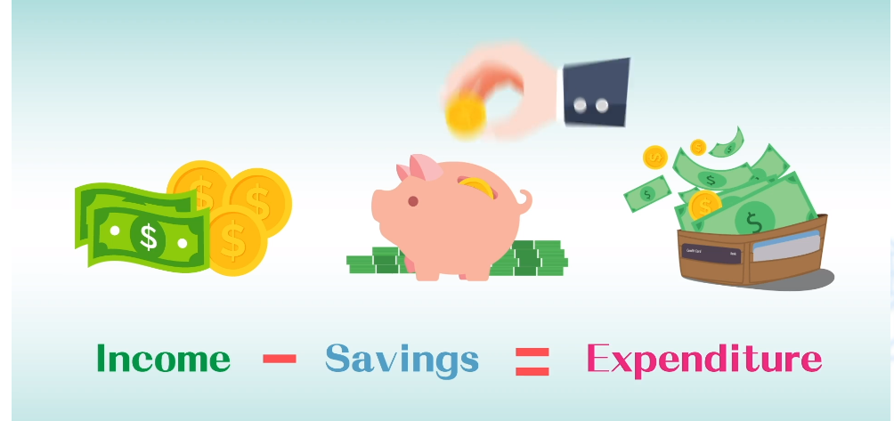

Saving plan
After listening to his brother’s advice, Chan Siu Ming decided to start his saving plan and he will take $150 out of his $250 pocket money as saving every week while the rest will be for daily expenditures.

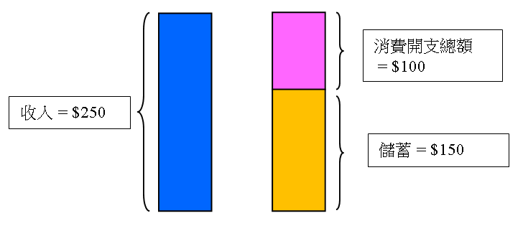
Do you think Chan Siu Ming’s saving plan will succeed?

Income = $250
Total consumption expenditure = $100
Savings = $150

“SMART” Saving Principles
Think about it:
Do you think $100 will be enough
to cover Chan Siu Ming’s daily expenses?
And then, Chan Tai Ming introduced the “SMART” Saving Principles to his brother.
Please refer to the website of the Investor and Financial Education Council (IFEC) https://www.ifec.org.hk/web/common/images/parent/tools-activities/smart-saving-kit.pdf, write down the specific contents of “SMART” Saving Principles, and discuss with your classmates how you can practise these principles in daily life.

Reflection on saving...
- Saving is a present for our future and it helps us attain more dreams.
- Saving is an insurance that can help us cope with some sudden or emergency needs in life.
- Develop the habit of saving. It is also a kind of practice on self-discipline.
- Don't wait till you are thirsty to dig a well and develop the habit of saving as early as possible.

How to practise these principles in daily life?

Based on students’ answers, analyse students’ reasons and values for the use of money / resources.
Worksheet 2: Money management skills: How to do budgeting?
Do you always find that your pocket money is not enough? Or you have enough pocket money, but do you make good use of it? It is not easy to spend your money wisely. We need to balance each type of expenditure and set priority for each expenditure item and make choices based on our budget. On the other hand, money can also be donated to people who are in need as well as invested for wealth accumulation.

- Allocate your monthly pocket money appropriately by filling in the following form.
Item | Amount Allocated | Type (e.g., expenditure, donation, saving)
e.g., transport
Total:

- Based on the table above, use a pie chart to illustrate your allocation of pocket money.



My plan on using pocket money

- What are the advantages of keeping a regular record of our expenditure?
Keeping a regular record of our expenditure helps us understand our spending habits better, so that it is easier to control our spending. For cutting expenditure, we may start with big items that take up a larger portion of our total expenditure and those that are relatively less important.

- For your daily expenditure items stated in Q.1, other than those you “need”, are there things that you “want”? Complete the table below by planning and listing your expected expenditure items for the coming month.

Item that you “want” | Amount | Priority | Reason

Extended Learning Activity: “Money Tracker - the Chin Family” Mobile Application
Students can make use of the “Money Tracker - the Chin Family” Mobile Application developed by the Investor and Financial Education Council, key in the information on income and planned expenditure you put down in Worksheet 2 and record the actual income and expenditure for the coming month. Compare the two after a month to understand your own spending habits and make a better plan and budget.

“Money Tracker - the Chin Family” Mobile Application

 |  | 
Android |  | iOS

Here are some tips on spending your money wisely:
1. List and jot down income and expenditure items so as to understand the expenditure pattern better and adjust the amount of expenditure and saving.
2. Set a saving plan and establish the habit of “saving before spending”.
3. Distinguish between “needs” and “wants”.
4. Refer to the “SMART” Saving Principles and set a saving target.

Reflection...
When you get pocket money from your parents and start planning your spending, do you feel the hard work of your parents and appreciate their effort for the family?

Worksheet 3: Financial needs at different life stages
At different life stages, we must ensure that we have sufficient money and money management skills to cope with different life events.


Chan Tai Ming always takes financial planning seriously. Other than making regular saving a habit, he invests part of his income monthly for accumulating wealth.
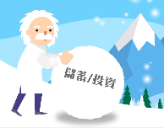


Saving /
Investment

The table below shows Chan Tai Ming’s monthly personal budget:
Item | Amount ($) | Item | Amount ($)
Salary | 23,000 | Saving | 5,000
Part-time income | 2,000 | Expenditure
 |  | Transport | 1,700
 |  | Food & beverage | 3,300
 |  | Entertainment | 2,000
 |  | Family expenses | 6,000
 |  | Others | 1,500
 |  | Donation | 500
 |  | Repayment of student loan | 2,000
 |  | Insurance | 1,000
 |  | Reserved for tax | 1,000
 |  | Investment | 1,000
Total Income | 25,000 | Total Expenditure + Saving | 25,000
Contents related to “repayment of student loan”, “insurance” and “investment” will be covered in latter parts of this resource. Teacher may explain the above contents further depending on students’ interest, ability and prior knowledge.
“Insurance” gives financial protection against unforeseen incidents and other risks in life.

Activity 1: Give Chan Tai Ming a hand
Chan Tai Man plans to get married after a year. He starts preparing for the wedding. He estimates that the total expenditure (e.g., wedding banquet, photo-taking, renting of tuxedos and gowns, honeymoon trip, etc.) will be around $300,000. He will share the expenditure equally with his fiancee. He now has $80,000 saving to cover part of the expenditure of the wedding.

- Based on the above information, will Chan Tai Ming have enough money for the wedding after one year?
No. The sum of his existing saving, $80,000, and his saving in the coming year (around $60,000) is smaller than $150,000 (half of the $300,000). He can’t afford the wedding.

- What advice would you give to Chan Tai Ming so that he can realise his wedding plan? List two solutions and their pros and cons.
Suggested answers: (other reasonable answers are acceptable)
- Reduce the wedding budget (e.g., reduce the scale of the wedding and change to a cheaper wedding venue): The wedding can be held on schedule and there is no need to borrow money and incur interest expense, but the wedding may not be the perfect one.
- Reduce the daily expenditure for the coming year (e.g., reduce entertainment): The wedding can be held on schedule and there is no need to borrow money and incur interest expense, but there is a need to change the present living style.
- Increase income (e.g., take up part-time jobs): The wedding can be held on schedule and there is no need to borrow money and incur interest expense, but private time will be reduced.
- Sell part of the investment: The wedding can be held on schedule but will affect the original investment plan.
- Borrow from relatives or the bank: The wedding can be held on schedule but there is a need to pay interest and doing so may affect the relationship with relatives.
- Postpone the wedding plan: It can avoid borrowing money and the interest expense, but may affect his life plan (e.g., having a baby).
Main teaching points:
- You will have different financial needs at different life stages;
- How to achieve financial goals and meet expected expenditures by establishing financial management plans.



Appendix 1

Know more: Basic knowledge about insurance

Insurance can be broadly divided into life insurance and general insurance. Life insurance pays the beneficiaries a lump sum upon the insured’s death. On the other hand, general insurance offers indemnity given to an event of loss other than life, for example, personal injury due to accident or damages to your assets.

Insurance gives you peace of mind and some financial protection against unforeseen incidents and other risks in life. You may need insurance for many reasons, some of which include protecting your dependents in the event of your death, your ability to earn an income, your home, car, or other assets in case of theft or disaster.

Insurance is about managing risks. If you have insurance cover, you transfer part of the financial risk to your insurer (insurance company). Without insurance, you bear the financial risk by yourself. Incorporating insurance into your financial plan is necessary to protect yourself, your family and your assets, and safeguard against a wide range of risks.

Source: IFEC website.
https://www.ifec.org.hk/web/en/financial-products/insurance/basics/insurance-basics.page

Appendix 2
Know more: Consumption vs. borrowing

What is a credit card?
Credit card is a kind of non-cash payment method. When using a credit card for payment, you do not need to pay cash immediately. But in fact, you are borrowing from bank or card issuing company.
Generally, if the cardholder pays on or before the due date of the statement, he/she does not need to pay interest. However, if cardholder only pays part of the amount (or even paying the minimum payment only), the outstanding loan’s interest rate can be 30% p.a.* or 40% p.a..
*p.a. mean per annum or per year

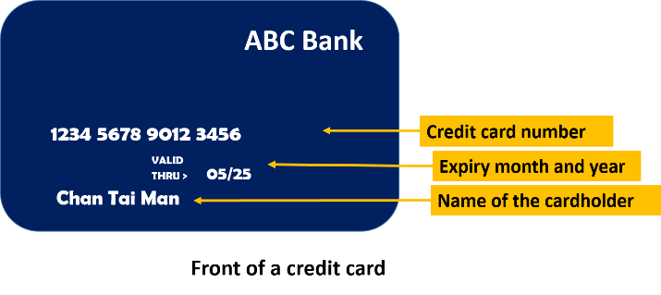

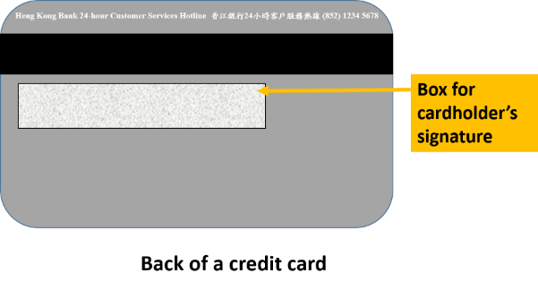

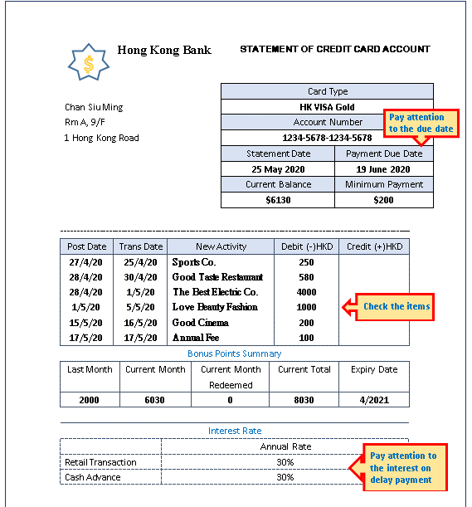
What do you know about the credit card statement?
ABC Bank

Five top tips on using credit cards
Visit the website of the Investor and Financial Education Council to understand the five top tips on using credit cards:
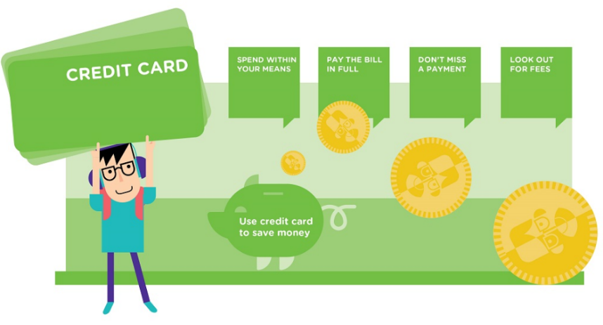
https://www.ifec.org.hk/web/en/other-resources/hot-topics/top-5-credit-card-tips.page

Source: IFEC website.
Think about it: Spending with credit cards
When we pay on time, no interest is required. At the same time, we can accumulate points for redemption of gifts and enjoy credit card discount offers from merchants. Does that mean the more you spend, the more you earn?
- Though there are benefits of using credit cards, we must not form the habit of “impulse buying” and spend more than our ability to repay.
- As a responsible consumer, you should know that you have to repay when you borrow, and the amount will have to be deducted from your future income. We have to use credit cards appropriately. Think twice to see if there is a need. Do not spend in advance and leave your credit card balance unpaid.
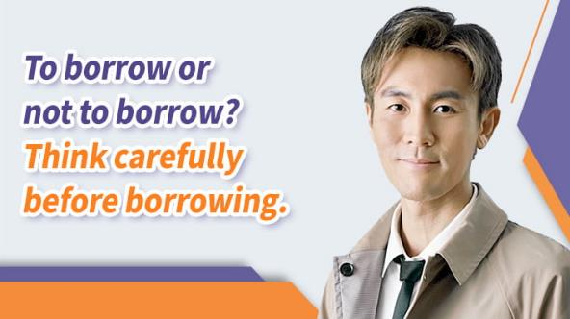

Source: IFEC website

Appendix 3

Know more: Overspending may lead to bankruptcy

Filing for bankruptcy may solve a financial problem?
Filing for bankruptcy is a legal process under which the court declares you unable to pay your debts. In some cases, bankruptcy can be an option for getting out of a bad financial situation, although you’ll be placed under a number of restrictions.

Consequences and costs of bankruptcy:
- You will be classified as bankrupt for four years and the Official Receiver (or a trustee) will look after your financial affairs.
- You won’t be allowed to make major purchases such as a flat or a car.
- You won’t be able to apply for further loans.
- Your provident fund may be used to repay your creditors.
- Public records related to bankruptcy will be noted on your *credit report.
- During bankruptcy, you cannot be a director of a company or operate a business. You may also be barred from working in particular trades and professions.
- Once a Bankruptcy Order is made, the Official Receiver will advertise the Bankruptcy Order in the Gazette and in an English- and Chinese-language newspaper.
- You may risk losing your job or professional qualifications.

*Credit reports contain information about an individual's background and credit history. Credit agencies gather data about your credit history from their members (such as banks and finance companies), then make that information available to banks and other lenders when they are reviewing your loan or credit application.

Source: “IFEC” website
https://www.ifec.org.hk/web/en/moneyessentials/debts-and-borrowing/bankruptcy.page

Think about it: Why should I borrow?
If money is not enough to cover one’s expenses, some may choose to borrow money, but they will have to pay interest for the money they borrowed. Some people think that borrowing is to spend your future money. So what in fact is borrowing? Is it a good way to solve the problem of not having enough money?

Generally speaking, borrowing means one uses future consumption in exchange for current consumption. According to Irving Fisher, an economist, as consumers are impatient, they want to consume more now. But there is a cost involved in early consumption, which is called interest. Interest is not necessarily measured in terms of money; any cost involved in early consumption can be called “interest”. Assume that I am hungry and I borrow 3 buns from you and return 4 buns to you later on. The additional bun is the interest.

Even though there is not any need to borrow at the current stage, you need to give careful consideration in case you have to borrow in the future. You should know that you have to repay when you borrow and the amount will have to be deducted from your future income. Therefore, it is better to cultivate the habit of saving on usual days, so that we can use our savings to meet the expenses when we need them in the future.
Main teaching points：
- To understand responsibilities, costs and risks of borrowing;
- To understand that even though there is not any need to borrow at the current stage, students need to give careful consideration in case they need to borrow in the future;
- To help students understand that borrowing is not the only option and they can save first to pay for future spending.

If cost is involved in borrowing, why do people borrow?
Suggested answers: (other reasonable answers are acceptable)
The borrowers are willing to pay the borrowing cost so as to meet their need for immediate spending.
They may wish to satisfy their immediate wants but fail to consider the consequences.
They cannot pay a large sum of money now (e.g., buying a flat) so that they have to borrow money and repay the money by instalments.
People may be affected by advertisement and believe that the interest rate will not be too high and they will be able to repay the money.

What are the factors we should consider before borrowing money?
Suggested answers:
Before borrowing, we should balance the need for spending and our ability to repay the debt. In addition, we need to consider the stress brought by owing a debt.

Appendix 4

Know more: The difference between payment by credit card and credit card cash advance

 | Payment by credit card | Credit card cash advance
Is it a kind of borrowing? | When you use a credit card for consumption, the bank pays for you in advance and you need to pay the bank back later. So it can also be considered as borrowing | Generally, credit cardholders can get cash directly from the ATM or transfer money by other means to use the credit limit. It is a very convenient but expensive way of borrowing
Interest | - If you pay in full on or before the due date, there is no interest;  - if you pay after the due date, the interest rate can be 30% p.a. or more | The annual interest rate for credit card cash advance is generally 30% or more
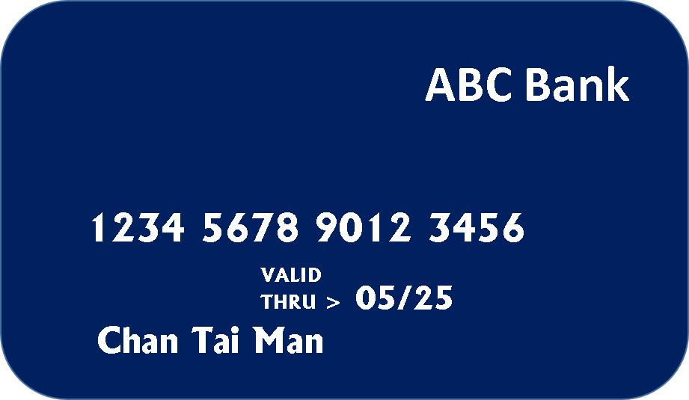
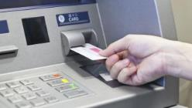

Source: IFEC website.
Worksheet 4: Unveiling the interest rate of credit card cash advance
Ng Man Keung is a fresh university graduate. Although he has not found a job, he has a debt of $10,000. He hopes to repay it in a year.

One day, the credit card overdraft (loan) scheme launched by ABC Bank caught the attention of Ng Man Keung. He thought it was a feasible way to pay off his existing debt. So he got the information for reference:

Simple interest calculation

Principal x interest rate
x time period
ABC Bank
Credit Card Cash Advance Service
By using this service, you can withdraw money anytime to cope with any sudden financial needs. Cash advance ensures that you have sufficient cash flow and manage your money more effectively.

We help people who are in need and our interest rate is the lowest in Hong Kong, only 3% per month. Don't hesitate to join now!

For enquiries, please call 1234 5678
Interest will be calculated from the date of the loan in compound interest on a daily basis
Warning: To borrow or not to borrow? Borrow only if can reply!

Compound interest calculation

Principal x
(1+interest rate)^{number of periods}
– Principal

Suppose Ng Man Keung wants to get a cash advance of $10,000 with his credit card and expects to settle the debt after a year (i.e., 12 months).

If the interest is calculated at a simple interest rate of 3% per month, after one year Ng Man Keung has to pay:
$10,000 × 3% × 12 = $3,600

If the interest is calculated at a compound interest rate of 3% per month, after one year Ng Man Keung has to pay:
$10,000 × (1+3%)¹²- $10,000 = $4,258

(Remark: Students only need to understand the power of compound interest; there is no need to require them to perform calculations. To understand the steps for compound interest calculation, please refer to the next page “Know more”.)

Appendix 5
Know more: Calculation of compound interest

- Calculate how much interest shall Ng Man Keung pay after one year (12 months) at 3% monthly interest rate compounded monthly:

Period (month) | Sum of principal and interest if the interest is calculated at 3% monthly interest rate compounded monthly
1 | $10,000 × (1+3%) = $10,300  [i.e., 10,000 × (1+3%)¹]
2 | $10,300 × (1+3%) = $10,609  [i.e., $10,000 × (1+3%) × (1+3%) = $10,000 × (1+3%)²]
3 | $10,609 × (1+3%) = $10,927  [i.e., $10,000 × (1+3%)² × (1+3%) = $10,000 × (1+3%)³]
4 | $10,927 × (1+3%) = $11,255  [i.e., $10,000 × (1+3%)³ × (1+3%) = $10,000 × (1+3%)⁴]
5 | $11,255 × (1+3%) = $11,593  [i.e., $10,000 × (1+3%)⁴ × (1+3%) = $10,000 × (1+3%)⁵]
6 | $11,593 × (1+3%) = $11,941  [i.e., $10,000 × (1+3%)⁵ × (1+3%) = $10,000 × (1+3%)⁶]
7 | $11,941 × (1+3%) = $12,299  [i.e., $10,000 × (1+3%)⁶ × (1+3%) = $10,000 × (1+3%)⁷]
8 | $12,299 × (1+3%) = $12,668  [i.e., $10,000 × (1+3%)⁷ × (1+3%) = $10,000 × (1+3%)⁸]
9 | $12,668 × (1+3%) = $13,048  [i.e., $10,000 × (1+3%)⁸ × (1+3%) = $10,000 × (1+3%)⁹]
10 | $13,048 × (1+3%) = $13,439  [i.e., $10,000 × (1+3%)⁹ × (1+3%) = $10,000 × (1+3%)¹⁰]
11 | $13,469 × (1+3%) = $13,842  [i.e., $10,000 × (1+3%)¹⁰ × (1+3%) = $10,000 × (1+3%)¹¹]
12 | $13,842 × (1+3%) = $14,258  [i.e., $10,000 × (1+3%)¹¹ × (1+3%) = $10,000 × (1+3%)¹²]

Note: If you cannot pay the debt in full, the interest will be rolling like a snow ball and will become bigger and bigger!
Total interest | = sum of principal and interest at the 12th month ─ principal  = $14,258 – $10,000  = $4,258

Extended Learning Activity: Compare two different kinds of loans
Read Source 1 and Source 2 and answer the questions.

Source 1: Tertiary Student Finance Scheme (Extracted)
The Tertiary Student Finance Scheme (TSFS) provides means-tested financial assistance to full-time students who are in need. It aims to ensure that no eligible student who has been offered a place in one of the institutions covered by this scheme would be unable to accept it because of lack of means. Financial assistance is provided in the form of a grant and/or loan. The TSFS loan(s) and the interest accrued are repayable in 180 monthly instalments at an annual interest rate of 1% within 15 years, after one’s graduation or when the course has officially ended.
Source: Student Finance Office (downloaded on 20 April 2020)

Source 2: Credit Card Cash Advance
Many people criticised credit card companies for charging high interest rates and described them as “loan sharks”. It was pointed out that a credit card's interest rate is compound and calculated on a daily or monthly basis, which can be up to 50% for those who have not repaid for two consecutive instalments. It indicates that the interest rate on credit loan is very high. With the compounding effect, the accumulated interest may be even higher than the original cash advance eventually.
Source: Consolidated newspaper reports

Compare the similarities and differences between credit card cash advance and the Tertiary Student Finance Scheme.
 | Credit card cash advance | Tertiary Student Finance Scheme
Operator | Credit card companies / banks/ other financial institutions | The Government
Purpose | Make profit by allowing people with financial need to use the credit card to get a cash loan and charging high interest rates on the loan | Provide financial assistance to full-time students studying in tertiary institutions so that they will not be deprived of access to education because of financial difficulties
Eligibility | Credit cardholders | Full-time students who have passed the family income and asset test
Interest rate | Interest is usually calculated on a daily or monthly compound basis | Annual interest rate at 1%

If you need to apply for a loan when you go to university in the future, which of the above methods would you choose? Explain your choice.
(Students may answer with valid reasons based on the above information.)

Summary

- Money can be used for consumption, investment, saving, donation, etc.
- Some basic principles of using money: Spend where necessary; distinguish between needs and wants; know how to prioritise and choose your consumption items; live within your means, etc.
- Recording daily expenses can help us understand our personal consumption habits, and we should often reflect on the proportion of expenses on different items.
- Cultivate the habit of saving, save first before consumption, use our savings to cope with any necessary expenditure, and use our savings to increase our wealth.
- Understand the responsibilities, costs and risks of borrowing (e.g., the responsibility of repaying the principal and the interest, the cost of paying interest, the risk of being unable to repay the debt, the stress brought by owing a debt, etc.).
- Understand that even though there is not any need to borrow at the current stage, students need to give careful consideration when there is a need to borrow in the future

Worksheet 5: Well spent or not?
Values education: Guide students to think of the purpose of our consumption, what kind of life we want to live, and then review our consumption behaviours.
Consumption is part of our life. Some people choose to pursue more material enjoyment and live a more luxurious life. However, some people like to live a simple life and do not want to be consumption slaves.

What is the reality? What actually is a simple life? Please read Source 1 and Source 2 and then answer the questions.

(Note: Source 1, Question 1 and Question 2 in this Worksheet are extracted and adapted from Unit 1 Personal Budget in the “Junior Secondary Money Management Teaching Package” produced by the IFEC.
Website: https://www.ifec.org.hk/web/en/other-resources/programmes/junior-secondary-money-mgmt-pkg.page)

Source 1: Tertiary Student’s Excessive Consumption Makes Bankruptcy Common
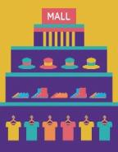

Source 2: Lok Yi’s Diary
Lee Tai Keung said, “I am currently studying in the university, and I often go out to eat with my hallmates. I also meet my secondary school classmates during my free time, and I have to buy some fashionable clothes so that I would not be behind the times. On festive occasions, I will celebrate with my friends and we will have buffet meals in luxurious hotels. Moreover, I always pay with my credit cards and I only repay the minimum payment monthly.”
Hong Kong News
Hong Kong Daily
2018-03-02
Note: When you use a credit card for shopping, in fact the bank pays for you in advance and you need to pay the bank back later. So it can also be considered as borrowing.
Tertiary Student’s Excessive Consumption Makes Bankruptcy Common
[Summary reports] A research shows that the number of tertiary students declaring bankruptcy in 2016 has increased compared with last year. A social worker found that some tertiary students apply for loans or credit cards to invest in the stock market, and for entertainment. He had contacted a young man who went bankrupt due to buying gifts for his girlfriend. Youth experts pointed out that young people are easily tempted by materials. Many people do not consider their real needs when shopping, but merely conform with the others. It is recommended that young people should think about their real needs and affordability before making purchases.
XX.XX.20XX Sunny
I have read a book called “Simplify Your Life” written by Elaine St. James today. The author mentioned about a new attitude of life, that is, to live a simple life. She has chosen to live a simple life because she wants to live freely and she wants to live a harmonious and meaningful life.
I still remember I loved shopping so much in the past. I went shopping after school every day before returning home. I bought a lot of things such as cosmetics, clothing and accessories. I always thought I did not have enough pocket money. When I did not have enough money, I would do some part-time jobs. Although it was hard, I thought it was worthwhile because I could get what I wanted. However, after reading this book, I start to think about my living. Do I really have a happy life? I had short moments of happiness, but in return, I gave up my sleeping time and the time with family and friends. When I recall the life that was controlled by consumption, I realize that I was not truly happy.
A simple life does not necessarily mean a poor life, or a life without consumption. On the other hand, a simple life aims at protecting the environment and avoiding wastes. By doing so, we can be released from unlimited wants.
I have decided to quit squandering today. I will only buy things that I need. Also, I will not be controlled by consumption anymore and I will always feel satisfied and stay happy.

Source: Adapted from 《消費洪流氾濫 簡樸生活知足尺度》, Singtao Daily.

Based on Source 1, why do you think Lee Tai Keung’s approach to financial management is inappropriate? Why? If you were his friend, can you give him some advice?
It is because he did not consider whether his income could afford the expense before spending. He blindly pursued the trend without differentiating between “want” and “need” items. In addition, he only repaid the minimum payment, resulting in hihg high interest charges that make it difficult for him to repay the debt in the future.

I will remind him not to blindly pursue the trend. Money should be spent on equipping yourself. Celebrating special occasions with your friends does not mean you have to have buffet meals in luxurious hotels. You can choose a cheaper way to celebrate.

You should give careful consideration to the use of credit cards so as not to develop the habit of “spending future money”.

According to Source 1, what are the reasons for some young people’s excessive consumption?
In a research conducted by the Consumer Council, it is found that: the habit of excessive consumption is the main reason for bankruptcy and repeated bankruptcy.
Suggested answers:
They are easily tempted by materials.
Many people do not consider their real needs when shopping, but merely conform with the others

According to Source 2, why does St. James choose to live a simple life?
St. James chooses to live a simple life because she wants to live freely and she wants to live a harmonious and meaningful life.

According to Lok Yi’s diary, list three principles of a simple life.
1. Always feel satisfied and don’t be controlled by consumption;
2. Only buy things that you need;
3. Protect the environment and avoid wastes

What did Lok Yi get from shopping in this article? What was the cost of her shopping?
She had only short moments of happiness during shopping. Because she loved shopping, she had to do part-time jobs to make extra money. In doing so, she gave up the time for sleeping and gathering with friends and family.

(Challenge question) Why does Lok Yi think she would be happier if she lives a simple life?
Lok Yi thinks her life was controlled by consumption before. To pursue the happiness from shopping, she had to give up a lot, including time for gathering with friends and family. As a result, she wants to live a simple life to free herself from unlimited wants and enjoy genuine happiness.

- Based on the knowledge about consumption learned above, reflect on your consumption patterns and identify areas for improvement, and share with your classmates.
Students can review and reflect on their own consumption patterns and behaviours by referring to the information provided.


Main teaching points:
Help students reflect on and review their own consumption patterns and behaviours.

Values Education: It is more blessed to give than to receive. It is joyful when you help others. When time and budget allows, donate money and get involved in volunteer work. (Extended Reading: Appendix 10 “Know more: The good deed of a good person”).

WHAT MONEY CAN BUY…
A house, but not a home.
Medicine but not health.
Luxuries but not culture.
A book but not knowledge.
Amusements but not happiness.
A clock but not time.

Extracted from the web

0Worksheet 6: Services provided by financial institutions
Students can learn about the financial services provided by financial institutions through the following scenarios in daily life.
In our daily life, we often use different financial services provided by banks or other financial institutions, such as various payment transactions, investments, deposits, etc. Refer to the following scenarios, what are the related financial services? What are the institutions in Hong Kong that provide the related services?
I want to deposit $10,000 into my savings account. Thank you!
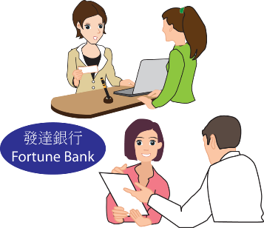
Hello! What can I help you?
A

My computer company is in need of cash flow. Can you help?

Mr Wong, our bank has a favourable loan plan which can help you!

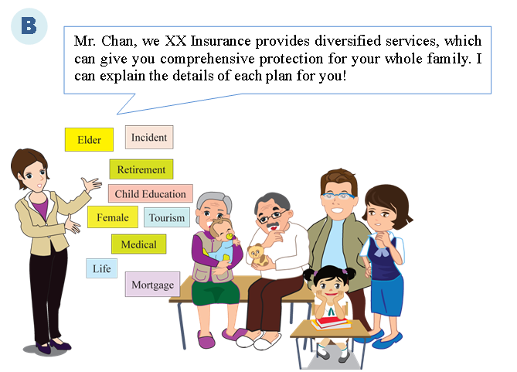
Accident

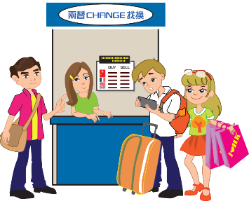
C
We want to exchange money for 1,000,000 Yen for our honeymoon in Japan.
Please help me transfer USD20,000 to the US for my son’s living expenses for studying abroad.



D

I want to buy a property for long term investment, but I don’t have enough liquidity...

I have a certain amount of savings and want my wealth to grow steadily.

E

You can buy shares. Apart from receiving dividends, share price may increase too, so that your wealth will grow.

Investment involves risks and the prices of securities (shares) may sometimes fluctuate dramatically. The price of a security may move up or down, and may even become valueless. There is no guarantee that you will make money from your investment. You may also suffer a loss.

Please refer to the above scenarios and complete the table below.
What are the related financial services? | What institutions in Hong Kong provide related services?  Give one example
- Deposits and loans | Deposits: Banks  Loans: Banks, financial services companies
- Insurance | Insurance companies, banks
- Foreign exchange trading and international money transfer | Foreign exchange trading: Foreign exchange dealers, securities companies, banks  International money transfer: Banks, post offices
- Mortgage | Banks or some non-bank institutions (e.g., property developers and financial services companies)
- Shares trading | Securities companies, banks

Appendix 5
Know more: Virtual banks

A “virtual bank” may simply refer to “a bank that is purely online”, which has no physical branches. It operates primarily through fintech and the Internet.

Benefits of virtual banks
Virtual banks can significantly save on rent and manpower. Coupled with the innovation and improved efficiency made available by fintech, they can offer competitive, personalised and convenient banking services and an all-new experience to customers.

Key points to note for using the services provided by virtual banks
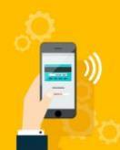
- The online service model may not be suitable for everyone.
- It is anticipated that virtual banks will only offer basic banking services such as account opening, deposits and loans during the early stage of their operations.
- It is very important to be aware of technology-related risks with virtual banking. While virtual banks must have effective network security measures, consumers should also pay attention to network security.
- Beware of fraudulent websites, forged e-mails and similar scams.

Source: IFEC website
https://www.ifec.org.hk/web/en/financial-products/fintech/virtual-bank/index.page

Worksheet 7: Many a little makes a mickle!
We have learned of the power of “compound interest” in Worksheet 4. We can also make good use of the snowball effect of compound interest to help our wealth to grow. We may use our savings as the principal for investment and the return from investment can be compounded as well. That means the principal and return of this round can be reinvested into the next round for investment.

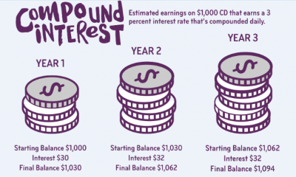
Source:
“Ally do it right” website
https://www.ally.com/do-it-right/banking/what-is-compound-interest-and-how-does-it-work/

Suppose the annual rate of return on investment is 5%. If you start saving or investing $200 per month at the age of 15, you can get back more than $500,000 at the age of 65. If you start at the age of 25, you will only get back about $300,000 when you are 65 years old. If you start at the age of 55, you will only get back about $30,000. So it is good to start saving or investing as early as possible.

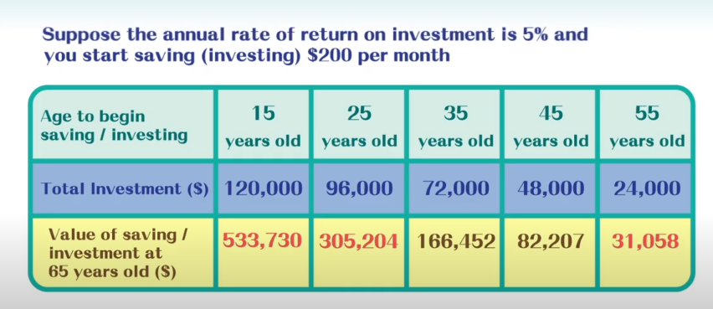

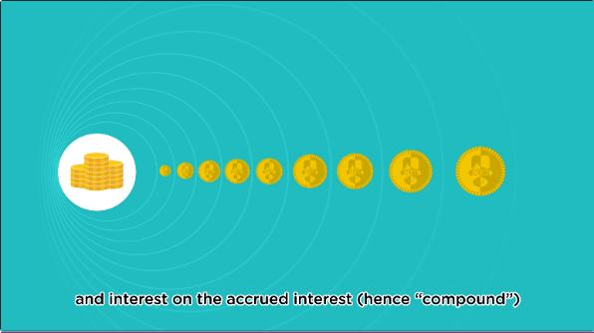
Video clip watching

 The power of compound interest
https://www.ifec.org.hk/web/en/other-resources/multimedia/video/animation-series.page?videoKey=compound-interest#topvideo

Appendix 6

Know more: Invest appropriately help fight inflation

Inflation risk
When price increases, the relative value of cash falls. When facing high inflation (i.e., when there is a persistent increase in general prices), the purchasing power of savings will fall. Invest appropriately can increase our wealth, and helps us fight inflation.
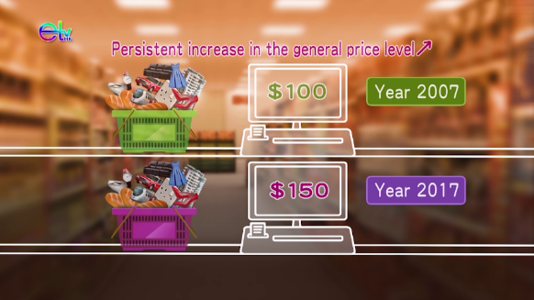

Source: “Introduction to Economic Concepts: GDP, Unemployment and Inflation”, Education Bureau
https://emm.edcity.hk/media/Introduction+to+Economic+ConceptsA++GDP%2C+Unemployment+and+Inflation/0_pbign930

Appendix 7

Know more: The key difference between shares, bonds and deposits
Main teaching points:
- Learn the major difference between shares and bonds (debentures);
- Understand that risks and returns are relative.

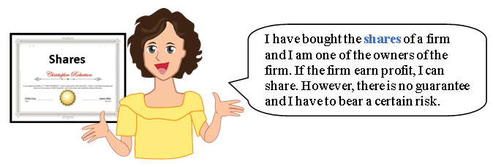
Once I have bought the shares of a company, I become a part owner of that company. If the company earns a profit, I can share a portion of it. However, there is no guarantee and I have to bear a risk.


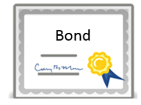
Once I have bought the bond of a company, I become the creditor / lender of that company. The bond can be regarded as a written acknowledgement of debt. As a bondholder, I can receive a steady interest return and the risk is lower than that of buying shares.


I choose to deposit money into a bank and this money becomes bank deposits. Though I earn very little interest, the risk is relatively low.

Hong Kong Deposit Protection Board
In case a member bank of Deposit Protection Scheme (DPS) fails, the DPS will pay compensation up to a maximum of HK$500,000 to each depositor of the failed Scheme member.

Appendix 8

Know more: The Hang Seng Index (HSI)
The HSI reflects the general trend of share prices

HSI trend (2017-2022)
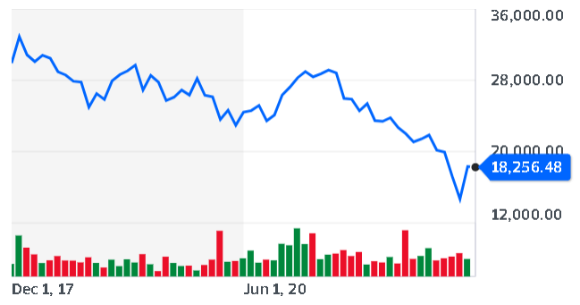

Source: Yahoo Finance webpage (downloaded on 16 Nov 2022)


Making good use of the snowball effect of compound interest can help us increase our wealth. We can even benefit the society and help other people in need if we have the ability.
Appendix 9
Know more: The good deed of a good person
At the end of 2018, the Community Chest was informed that a charitable fellow donated more than half of his estate to the organisation, with a donation amount of HK$460 million. This donation is the largest individual donation made to the charity in nearly 52 years since its establishment. The donor is Mr Kam Sik-hung.
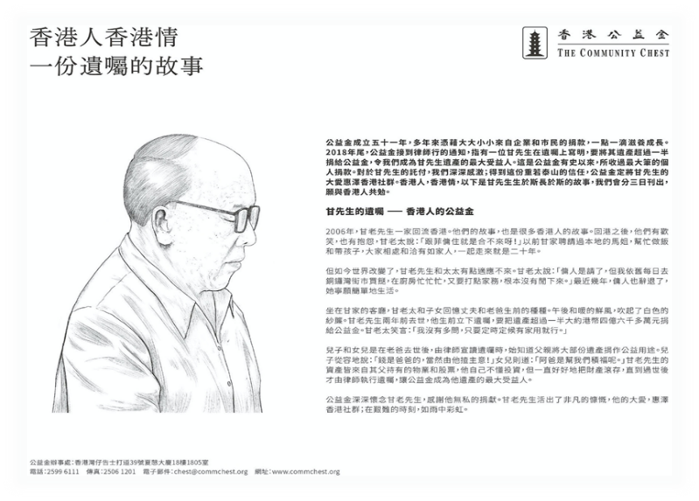
The Community Chest has published the story of Mr Kam in a number of Chinese newspapers for three consecutive days since 1 June 2020 to thank him for bringing a rainbow in the rain in difficult times for the people of Hong Kong by his selfless contribution to benefit the community of Hong Kong.

Mr Kam Sik-hung was a former teacher and civil servant. His wife stated that they worked and supported the family together. His assets were mainly properties and shares. He did not consider himself a good investor, but he just kept reinvesting his return from investment.
“The money is my father’s, of course he gets to decide”, Kam’s son said. “My father is helping us accumulate virtue”, Kam’s daughter said.
Mrs Kam smiled and said, “I didn’t ask. It was fine so long as he gave me the money to cover the family’s expenses on time.”

Source: Topick, The Hong Kong Economic Times

Video clip watching: Risk and Return
Please watch the video clip below to briefly understand the relationship between risks and returns.
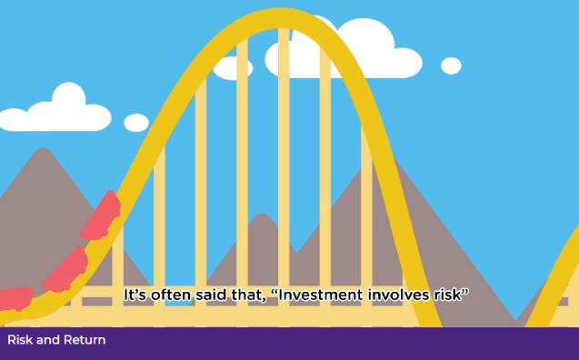
Risk and Return
https://www.ifec.org.hk/web/en/other-resources/multimedia/video/animation-series.page?videoKey=risk-and-return#topvideo
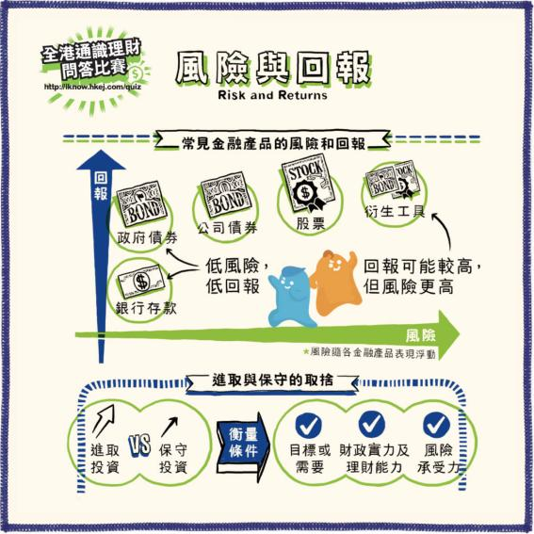

Source: Hong Kong Economic Journal Company Limited “Handy Finance” Webpage
(Chinese Only).
http://iknow.hkej.com/financeinfographics/
Don’t be greedy
There are different financial products in the market. Generally speaking, the risk of bank saving is relatively lower and the expected return is also lower. While the risk of investing in stocks is higher and the expected return is also higher. We should not believe the claim of “low risk, high return” investment to avoid falling into investment scams, and should be beware of claims of ways to make easy money. We have to always remember to use a legal and proper way to earn money.

Think about it:
Watch the video clip below and suggest some ways to avoid investment scams.
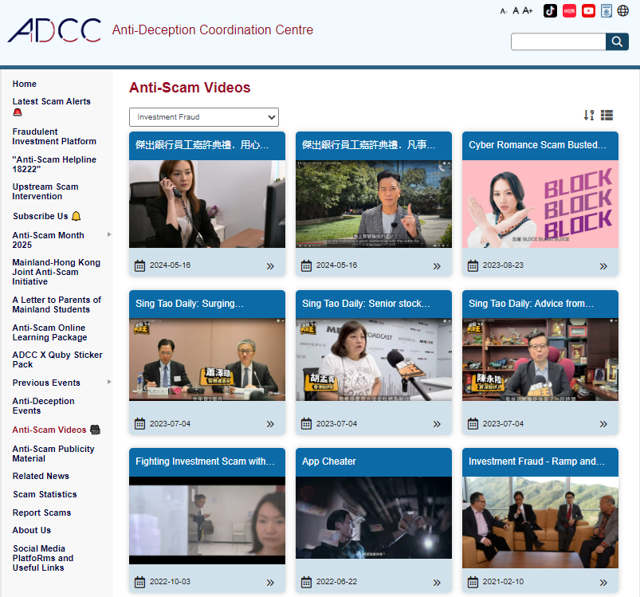

Source: Anti-deception Coordination Centre, The Hong Kong Police Force Website
https://www.adcc.gov.hk/en-hk/videos

Appendix 11
Know more: Other anti-deception information

- Investor and Financial Education Council Website
https://www.ifec.org.hk/web/en/moneyessentials/scams/index.page

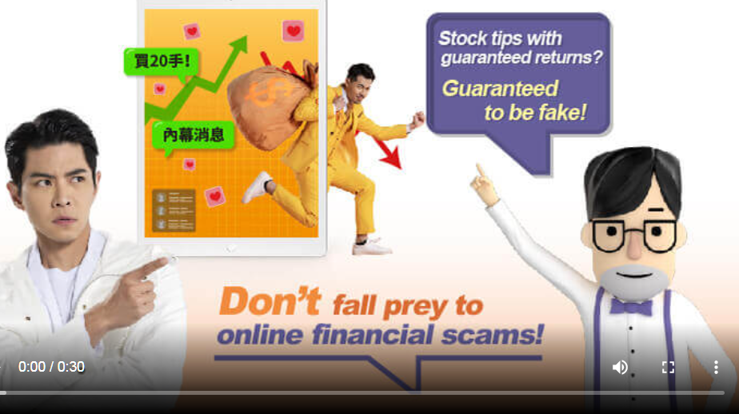

- The Hong Kong Police Force Anti-Deception Coordination Centre Website
https://www.adcc.gov.hk/en-hk/home.html

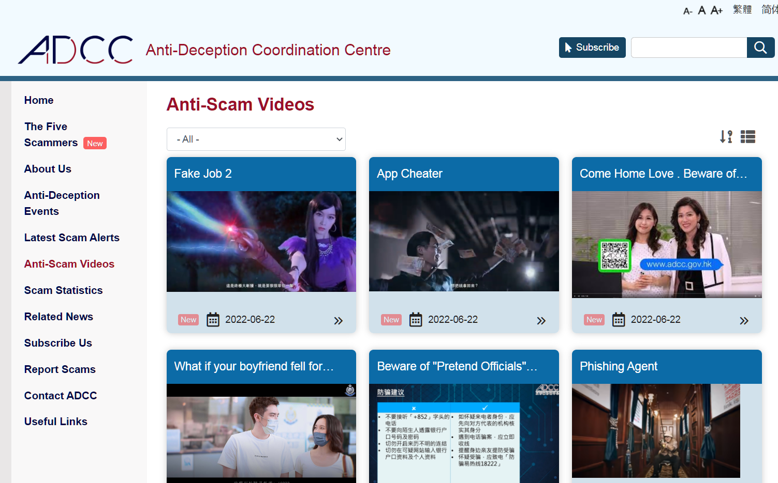

Appendix 13

Know more: Risks and returns of investment

Risks and returns are correlated. Generally, the higher the expected return of an investment product, the higher the risk and the potential loss. So we have to understand clearly our target and need before we invest.

Reduce the risks of price volatility by investment diversification
Prices of an investment may fluctuate dramatically. We can reduce relevant risks by investment diversification. For example, invest in a variety of asset types, like shares, debentures, funds, fixed deposits or foreign currencies, etc. Holding different types of assets, you can maintain an appropriate asset mix and diversify risks.

Summary
- The services provided by banks include deposit services, helping customers to open investment accounts for trading shares and debentures, providing different insurance schemes, lending services, mortgages, foreign exchange trading and other services.
- Generally speaking, risk and return are correlated. Therefore, when making investment, we should strike a balance between them, understand our needs, and make appropriate choices rationally to increase our wealth. In addition, investment involves risks. We should not believe the claim of “low risk, high return” investment to avoid investment scams.

Appendix 12

Know more: Responsibilities and rights of investors

Links (Slides 28-33): (Chinese only)
https://www.edb.gov.hk/attachment/tc/curriculum-development/kla/pshe/references-and-resources/cross-curricular-resources/JS_Financial_Education_Part3_2020_07.pptx

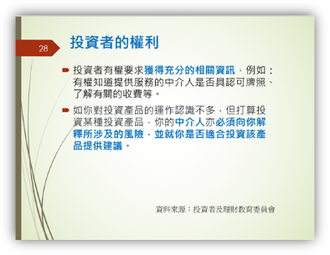
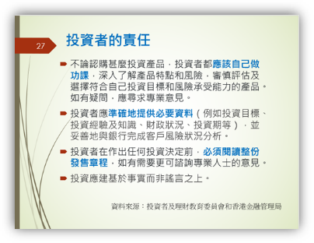
Homework: Revision of concepts
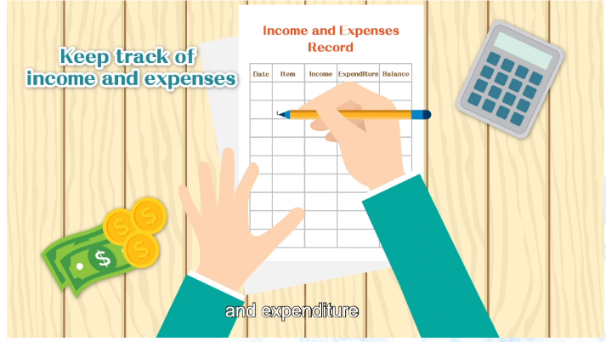
“3-minute Concept” Animated Video Clip
“Personal Resource Management: Managing Finance”
https://emm.edcity.hk/media/1_7xrefilc

Module 1.3: Financial Education
Main teaching points:
- Pay attention to the potential risks and traps of online shopping;
- Respect intellectual property rights.
- Enhance the awareness of national security (cyber security)
(Lesson 7 and Lesson 8)
Learning and Teaching Materials

Online Shopping
Introduction
With the popularity of the Internet, online shopping becomes a trend. When enjoying the convenience of online shopping, students should pay attention to the potential risks and traps and avoid being cheated. When shopping or having transactions online, we have to pay attention to protection of personal information and intellectual property rights.

Think about it: Online shopping is trendy?
Have you or your family member ever shopped online? What are the differences between shopping online and buying in physical stores? What should you pay attention to when shopping online?

Activity 1: Potential risks of online shopping
The following is the flow chart of online shopping:

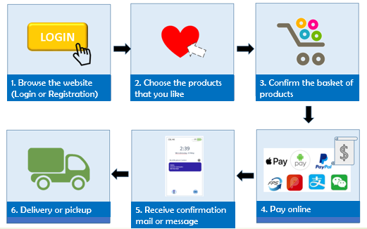
Hints: When teaching this part, teachers should help students understand the importance of proper use of the the Internet to the normal operation of society. A normally operated network is closely related to the orderly functioning of society (e.g. online shopping and financial services, etc.). Therefore, students are able to understand the impacts of improper use of the Internet or even cyber crimes on the general public.

For the concept of cyber security, please visit the website of “National Security Education Day”:
https://www.nsed.gov.hk/national_security/?a=national_security_main_focus#focus_box

For the concept of cyber security, please visit the website of “National Security
Education Day”: https://www.nsed.gov.hk/national_security/?a=national_security_main_focus#focus_box

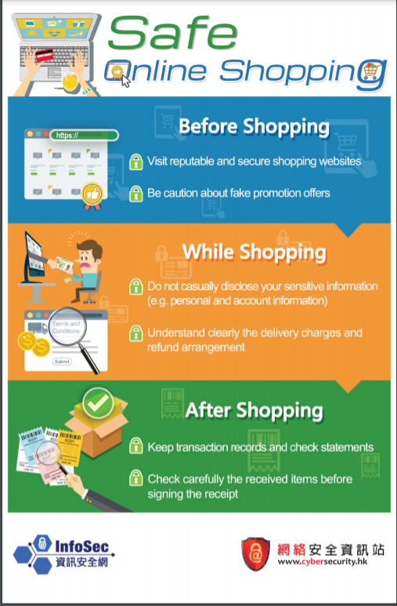

Source: “Cyber Security Information Portal” website
https://www.cybersecurity.hk/images/resources/safe_online_shopping_en.pdf

Based on the flow chart and the poster above, list two potential risks of shopping online.
Suggested answers (any two points):
- Sellers may sell at exceptionally low prices to attract buyers, but the products may turn out to be different from what buyers expect.
- The personal data of buyers may be used fraudulently by sellers for profits.
- The seller may request the buyer to deposit the payment to a designated bank account and refuse to trade face to face. The buyer may not be able to get the product in the end after paying for it.

Worksheet 8: Be cautious when shopping online
Refer to the information below and answer the questions:

Source 1: News related to online shopping
With technological advancement, online shopping is becoming more and more popular. According to a research conducted by the Census and Statistics Department, the percentage of people in Hong Kong who have online shopping experience increased from 16% in 2009 to 36% in 2018. Online shopping allows consumers and retailers to be free from time and geographical constraints. Prices are generally lower than those in physical shops. Online shopping has attracted more and more consumers, but at the same time, complaints about it have also increased a lot in recent years. According to the analysis of the Police, the most common trick used by fraudsters in online shopping or on auction platform is to claim that they are selling some goods and ask the buyers to provide e-mail addresses and phone numbers and to trade outside the platform. Once the buyers have followed the instructions and deposited the money into the fraudsters’ bank accounts, the fraudsters will disappear.

The Police remind the public to be vigilant when conducting online transactions. Buyers should ascertain the credibility of the seller and verify the seller’s identity before conducting online transactions; conduct transactions through an online trading system with identity authentication or through a reliable intermediary platform. When shopping online, one may consider trading in person as far as possible, and should carefully check the goods before paying. If there is any suspicion over the seller’s identity, stop the transaction at once, call the Anti-Scam Helpline 18222 or report to the Police.

On the other hand, the spokesman of the Consumer Council stated that, as some of the shopping websites are not established in Hong Kong, consumers might not enjoy the local legal protection if there are any problems. In addition, some websites are not responsible for the transactions carried out on them. In addition, consumers should pay attention to the protection of their personal information, and never disclose any personal account numbers and passwords, etc. to strangers. Online consumers must stay alert to avoid being cheated.

Source: Integrated from news.gov.hk, Census and Statistics Department website and Legislative Council website

Source 2: Screenshot captured of the chat history of an online shopping fraud that occurred during the pandemic outbreak.
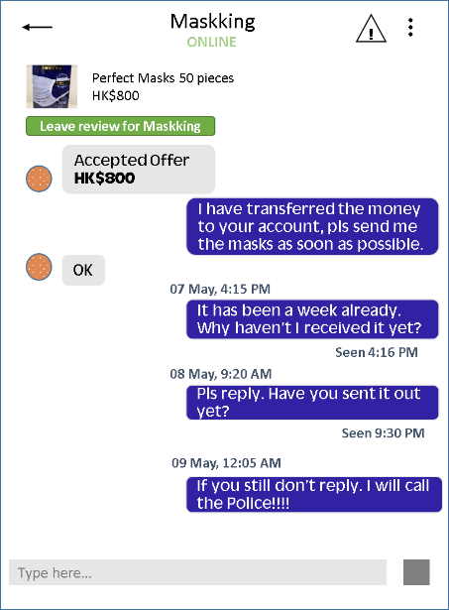

Based on Source 1, what are the advantages of online shopping for consumers?
Online shopping allows consumers to be free from time and geographical constraints. Prices at online shops are also generally lower than those in physical shops.

According to the Police, what is the most common trick used by the fraudsters?
The fraudsters claim that they are selling some goods and ask the buyers to provide e-mail addresses and phone numbers, etc. and to trade outside a reliable online system or intermediary platform. Once the buyers have followed the instructions and deposited the money into the fraudsters’ bank accounts, the fraudsters will disappear.

According to Source 1, how can we avoid the online shopping fraud illustrated in Source 2?
Buyers should ascertain the credibility of the seller and verify the sellers’ identity before conducting online transactions;
Conduct transactions through an online trading system with identity authentication or through a reliable intermediary platform;
When shopping online, one may consider trading in person as far as possible, and should carefully check the goods before paying;
If there is any suspicion over the seller’s identity, stop the transaction at once, call the Anti-Scam Helpline 18222 or report to the Police.

Collect a piece of news about online shopping fraud and share with classmates how to avoid being cheated.

Video clip watching
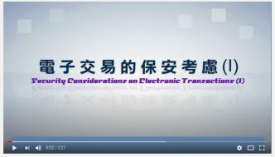

Security Considerations on Electronic Transactions (I) (2:27)
https://www.youtube.com/watch?v=aUwsIXvnjJQ

Key points:
- Electronic transactions refer to transaction activities conducted via an electronic system.
- Electronic transactions bring convenience, but also pose security risks. When conducting electronic transactions, users generally are required to input their user name, password and other sensitive information such as credit card number.
- Electronic transaction is a common target of phishing attacks.
- Attackers will use fraudulent emails or websites to get personal information from off-guard web surfers.
- When conducting an online transaction, the user should verify the authenticity of the website, read in detail the terms and conditions, carry out proper identity authentication and encrypt the data being transmitted.

Video clip watching
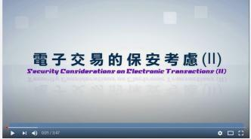

Security Considerations on Electronic Transactions (II) (3:47)
https://www.youtube.com/watch?v=PKyJcW4QN8Y

Key points:
When conducting electronic transactions, we should note:
- For organisations: 1. If input of sensitive information is required, the website should provide an electronic certificate of the server so that users can verify the website’s authenticity; 2. Card holder Identity Authentication Service should be adopted for payment; 3. Two-factor Authentication should be adopted for banking services.
- For individuals: 1. Do not carry out electronic transactions or use online banking services at public Internet access facilities; 2. Close all browser windows before conducting electronic transactions and log out after completing the transaction; 3. Stay vigilant when providing personal or account information; 4. Do not click on hyperlinks in dubious emails; 5. Do not use URL addresses of financial institutions generated from online search engines; 6. Log in your online account regularly to review the account status and last login date and to check if there are any suspicious transaction activities; 7. Adopt basic security measures on your computer.

Activity 2: More on online shopping
Which statement(s) about online shopping is/are correct? Put a “” in the appropriate box(es).
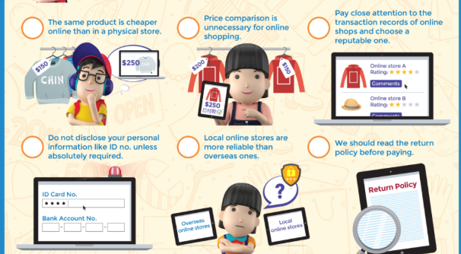
Source: “IFEC” website.
https://www.ifec.org.hk/web/common/images/parent/tools-activities/learn-online-shopping-en.png

Extended Reading:
“Safe online shopping”
Source: Cyber Security Information Portal
https://www.cybersecurity.hk/en/learning-shopping.php#slide-1
Some tips for online shopping:
1. Use secure online payment methods, e.g., use a trustworthy payment gateway and ensure personal information security.
2. Evaluate the online shop’s reputation and consult trusted people and websites when purchasing via an unfamiliar website.
3. Beware of the price and product reviews that are too good to be true, especially medical and health products.
4. Download and read the terms and conditions carefully before clicking the “agree” box.
5. Find out if you have the right to a refund and what the refund policy is, e.g., the conditions under which you can get a refund.
6. Exercise your right to refuse or opt out from direct marketing activities under the Personal Data (Privacy) Ordinance.
7. Pay attention to the delivery charge before making payment.

Source: Consumer Council: Online Retail – A Study on Hong Kong Consumer Attitudes, Business Practices and Legal Protection, and other relevant websites

Worksheet 9: What are intellectual property rights?
Respecting intellectual property is an indicator of modern civilized society. With the popularization of the Internet and online shopping, we need to know clearly what intellectual property rights are. What is online copyright infringement? Why should we respect intellectual property rights?

The Government of the Hong Kong Special Administrative Region (HKSAR) attaches great importance to the contribution of intellectual property rights protection to the economy. Recognising the importance of intellectual property rights protection, the Basic Law specifically provides in Articles 139 and 140 that the HKSAR should on its own develop appropriate policies and afford legal protection for intellectual property rights.* (*Article 139, paragraph 1 of the Basic Law stipulates that the Government of the Hong Kong Special Administrative Region shall, on its own, formulate policies on science and technology and protect by law achievements in scientific and technological research, patents, discoveries and inventions. Article 140 stipulates that the Government of the Hong Kong Special Administrative Region shall, on its own, formulate policies on culture and protect by law the achievements and the lawful rights and interests of authors in their literary and artistic creation.)

Read the three comics below and the website of the Intellectual Property Department (IPD) (https://www.ipd.gov.hk/en/ip-overview/ip-in-hong-kong/index.html) and answer the questions:
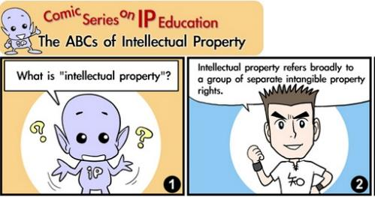
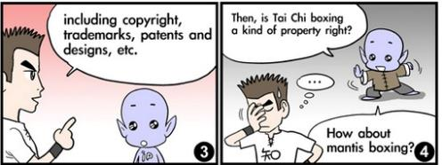

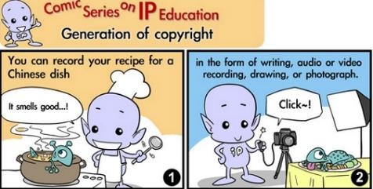
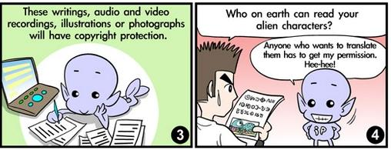
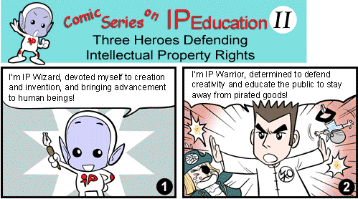

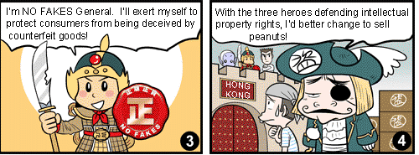
Source: Intellectual Property Department: Comics on IP
https://www.ipd.gov.hk/eng/promotion_edu/educational_corner/comics/index.htm
https://www.ipd.gov.hk/en/tools-resources/publications/learning-aids-comics/comics/index.html

What is “intellectual property”?
Suggested answers: (Extracted from the IPD website)
Intellectual property (IP) refers broadly to a group of separate intangible property rights, including trademarks, patents, copyright, designs, etc.

Why is intellectual property protection important?
Suggested answers: (Extracted from the IPD website)
- Protection of intellectual property rights protects creativity. The efforts of writers, artists, designers, software programmers, inventors and other talents need to be protected so as to create an environment where creativity can flourish and hard work can be rewarded.
- Hong Kong is a creative place. Our film production, television production, sound recordings production, publications, fashion and jewellery design and graphical design and production skills are known world-wide and enjoy a ready market overseas.
- Hong Kong is an international trading centre. We need to provide the necessary intellectual property rights protection to our investors to assure them of a free and fair environment in which to do business. Thus, it is in our very interest to protect intellectual property rights.

Suggest some activities to raise students’ and the public’s awareness of intellectual property rights protection.
(Students may suggest some appropriate activities.)

Creative Commons

Protection of intellectual property rights protects creativity. However, if the creative idea can be shared among more people, more people in society will be benefited.
On one side is the traditional “all rights reserved.” At the other extreme is the free-for-all “public domain” in which creators have no control over the use of their work. Creative Commons enables creators to opt for “some rights reserved” and others are allowed to use it as well. The organisation tries to leave the creators with a flexibility to keep “some rights reserved” and offering others the rights to use under certain conditions.

Source: Creative Commons Hong Kong. https://hk.creativecommons.org/faq

Extended Learning Activity: “I Pledge” Campaign
Refer to the details on the website below and join the “I Pledge” Campaign promoted by the IPD: https://www.ipd.gov.hk/eng/promotion_edu/i_pledge.htm
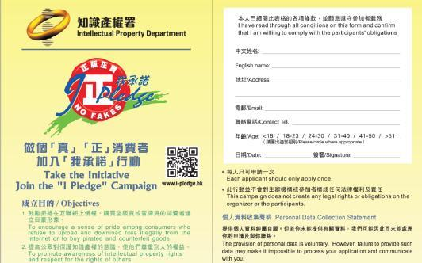
Summary
- When shopping online, one should pay attention to potential risks and traps when buying online and avoid being cheated. We also have to pay attention to the protection of personal information and intellectual property rights.
- Intellectual property is the name commonly given to a group of separate intangible property rights. These include trademarks, patents, copyright, designs, trade secrets, etc.
- We should respect and protect intellectual property, protect private property, protect the interest of the inventors and genuine intellectual property rights owners, so as to encourage more good creativity and products.
- Improper use of the Internet or cyber crimes would cause negative impacts on the general public. Apart from avoiding becoming victims of cyber world, we also need to enhance the awareness of the threats of cyber infrastructure and cyber crimes. We need to be responsible internet citizens and contribute to enhancing cyber security.
Appendix 13

Know more: Intellectual property rights
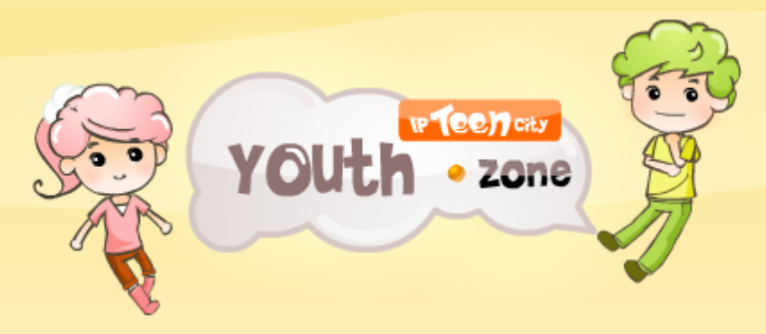

https://www.ip-kids.gov.hk/en/home/index.html

IP Game
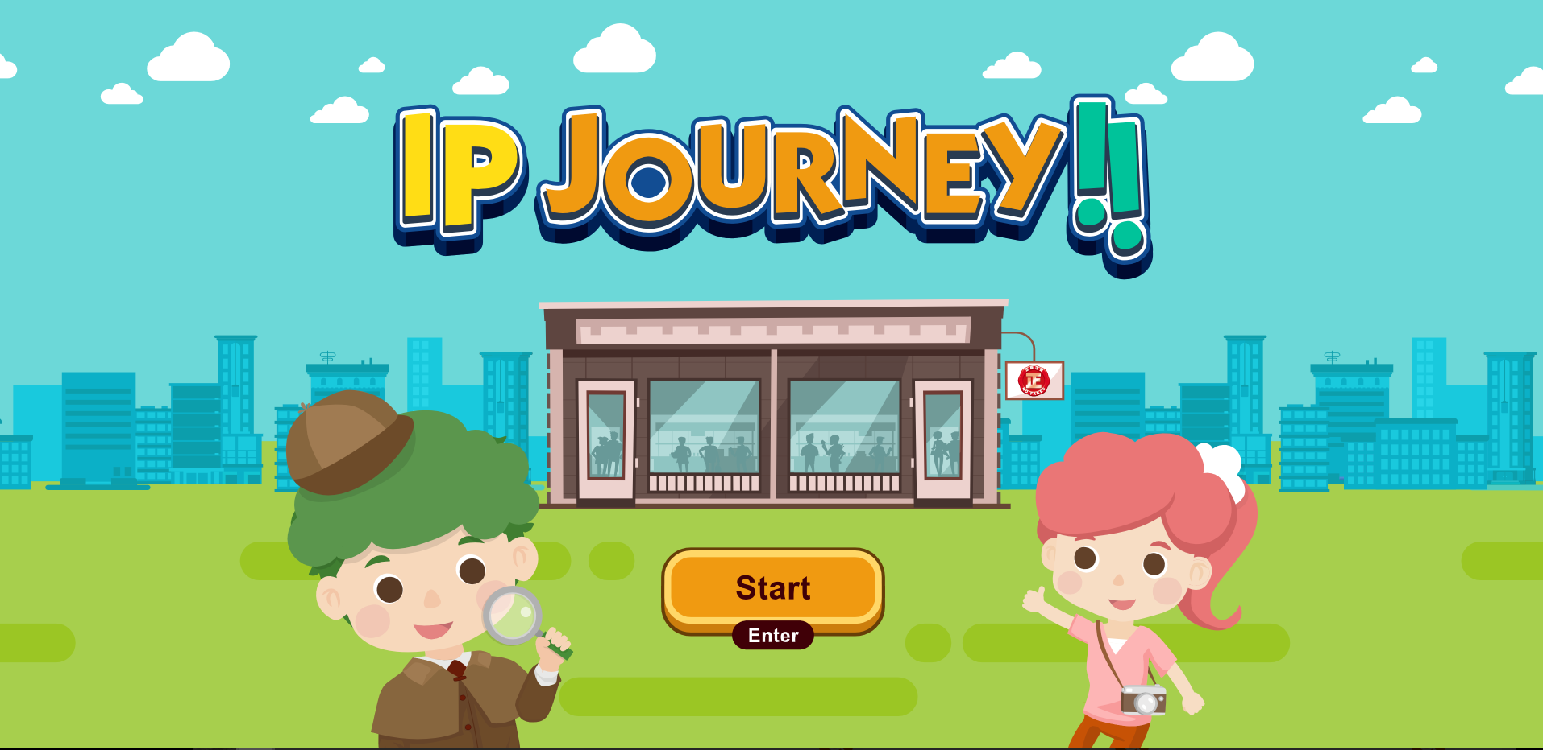
https://www.ip-kids.gov.hk/en/game/index.html
Module 1.3: Financial Education
(Lesson 9 and Lesson 10)
Set Activity: Students reflect on their daily consumption behaviours and the reasons that drive them to go shopping.
Learning and Teaching Materials

Green Consumption
Worksheet 10: What are your considerations when shopping?
Do you know how many consumption activities do we have every day? Our everyday consumption includes the breakfast bought in the morning, the snacks bought during recess and the stationeries bought after school, etc. What are the factors that affect our consumption decisions?

1. Let’s think of the reasons that drive you to shop.
To meet our real needs
To buy presents for a friend’s birthday, etc.
To perform the act of shopping

2. What are the considerations when you are choosing goods?

Environmental friendliness

Durability

Services

Packing

Quality
For example,
Price

The above can be classified as price factors and non-price factors. Considering the non-price factors, we can bring out the principles and responsibilities of choosing products or services.

Think about it:
As a consumer, is making payment our sole responsibility? Are there other responsibilities we have to perform?

Reading Material: Green Consumption
Main teaching points:
- We should consider the impact on society and the environment when we consume.
Do you have too many clothes in your wardrobe? Are there some clothes that have been left idle for a long time? How often do you buy a new pair of sneakers? “Consumption” is an activity that we often do. It can promote economic development, but “excessive consumption” causes damage to the environment. Therefore, we should practice “green consumption” and contribute to the sustainable development of society.

1. Principles of choosing goods or services
We should consider from both the personal and social perspectives when choosing goods or services. At the personal level, we should consider if the consumption is necessary. Will the consumption bring us an unnecessary burden? In addition, we should consider our social responsibilities. Consider the value of consumption from the perspective of environmental protection and fairness, and understand the impacts that consumption may bring to society. We should be cautious with our consumption, and think twice about its meaning and the value of goods so that we can have responsible consumer behaviours.

2. Responsibilities of consumers
2.1 Individual responsibilities
Consumers should be responsible for their consuming behaviours, avoiding excessive consumption which may lead to wastage. Before consumption, we should understand our needs, grasp the information of the goods, and consume cautiously. We should also consider the consequences; for example, if we can afford it; if we need to take a loan due to the consumption; if the goods are useful for us. Before the consumption, we should check the goods carefully; after the consumption, we should keep the receipts, instruction manuals, warranty cards, etc. for any possible future use. Besides, we should also reflect on our consuming behaviours.

2.2 Social responsibilities
Consumers should understand the social impacts of consumption in order to reduce unnecessary social costs arising from individual consumption. For example, consumers should have the vision of sustainable development, such as bringing their own bags, choosing goods with less packaging, and adopting green consumption (5R: Reduce, Reuse, Recycle, Re-evaluate, Rescue).

“Green Consumption” incorporates the ideas of “environmental friendliness”, “reduce”, etc. into our daily consumption, so as to attain full utilisation and reduce wastage of resources and lessen pollution. International environment experts use the term “5R” to represent this idea:

Reduce
Reduce unnecessary consumption. Avoid buying unnecessary or excessive goods.

Reuse
Choose reusable designs, reduce using disposable products.
Rescue
Protect endangered species, refuse buying related products.

Green Consumption
5R

Re-evaluate
Choose products that are natural or made from recycled materials.
Recycle
Choose products that can be recycled.

Consumers play a key role in global sustainability. We should practise 5R in our daily life and consumption. Other than pursuing a comfortable and convenient life, we should also contribute to the conservation of environment.

Worksheet 11: Do you practise green consumption?
Teachers invites students to reflect on their consumption behaviours, discuss in groups and share with their classmates.
Do you consider/implement the following principles in daily life? Think of three other green consumption behaviours that students can contribute to society and share them with your classmates.

 | Must | Always | Sometimes | Rare | N/A
Use energy-efficient lighting (e.g. energy-efficient light bulbs)
Think twice before buying clothes and won’t leave clothes idle or throw away too many clothes
Reduce the usage of disposable tableware
Choose products with environmentally-friendly labels
Avoid using products produced by harmful substances or methods

Green consumption and sustainable development

Sustainable development and sustainable consumption are closely related. According to the World Commission, sustainable development is defined as:

“Development that meets the needs of the present without compromising the ability of future generations to meet their own needs.”

For sustainable development to be achieved, it is crucial to harmonise three core elements: economic growth, social inclusion and environmental protection. These factors are interrelated and are of great importance to the healthy development of individuals and society.
Sustainable Development
Economic
Environmental
Social

- Economic aspect: It must be profitable economically, or project that is having loss must be offset from other profitable projects in order to maintain its sustainability.
- Environmental aspect: It refers to the minimization of harm to the environment.
- Social aspect: It refers to fulfilling human needs.

Take “consumption” as an example. It can promote economic development, but “over-consumption” causes heavy pressure on the environment and may cause various social problems. In the following, the impact of “over-consumption” on sustainability of society in terms of economic, environmental and social aspects will be analysed.

Economic aspect
“Consumption” is an essential activity in society. Citizens have to get daily necessities through “consumption”, and “consumption” can promote social-economic development, make people more well-off and improve quality of life. However, if there is “over-consumption” in which citizens and society cannot bear, there may be an economic crisis. For example, the financial tsunami is caused by an excessive amount of loans. Though “over consumption” is not the direct cause of the financial tsunami, it is related to irresponsible financial management.

Environmental aspect
“Over-consumption” encourages consumers to consume new products and reduce the life of products. It causes unnecessary usage of the world’s resources and directly causes unnecessary wastes, which lead to a heavy burden on the natural environment and uncountable natural disasters. For example, the production and use of products require the use of a large amount of energy, which will lead to global warming. The production process and waste disposal will also cause serious pollution to the environment, which will affect human health and destruct the ecological environment. Though nature can heal itself, our excessive use of resources and destruction of the environment have reached a critical level. We have to give urgent attention to the problem.

Social aspect
In order to increase competitiveness, manufacturers have increasingly globalised the production process, sales and waste disposal, leading to unfair trade, exploitation of developing countries, homogeneity of products, stifling of traditional culture and technology, dumping and monopoly, and increased disparity between the rich and the poor among countries, and other international problems.

On national, regional and individual levels, though consumption can stimulate economic growth, make the society more well-off and increase the living standard of the general public, “over-consumption” leads to a materialised society. People may focus on enjoyment and neglect other aspects of personal growth, which may indirectly lead to other social problems.

In order to attain sustainable development, we have to balance the economic, social and environmental factors and work together to build an inclusive, sustainable and adaptable future for our next generation.

Source: Websites of the Environment Bureau and the Education Bureau of the Government of the Hong Kong Special Administrative Region

Think about it:

Have you ever seen some items produced with consideration for sustainable development? When you go shopping, have you considered whether sustainable development principles are adopted in the packaging and production process?
Yes. For example, coffee ground soap.
Buy products or services from corporations which adopt sustainable development principles in their production or procurement process.

Low Carbon Living Calculator

Let’s calculate our carbon emission together!



https://www.carboncalculator.gov.hk/en



Self-learning materials

Self-learning material 1: Learn from celebrities
Read the following links (Slides 29-40) (Chinese only)
https://www.edb.gov.hk/attachment/tc/curriculum-development/kla/pshe/references-and-resources/cross-curricular-resources/JS_Financial_Education_Part1_2020_07.pptx
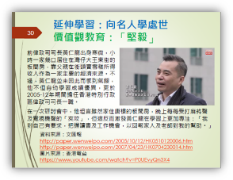
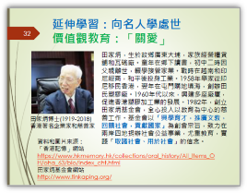
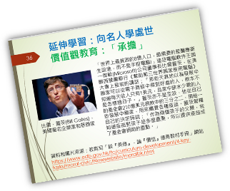

Think about it:
What inspirations for your life planning have you got from the experiences and stories of successful celebrities in the PowerPoint file?

Self-learning material 2: Intellectual Property Rights Protection

A total of 1003 members of the public responded to the Survey on Public Awareness of Intellectual Property Rights Protection 2018. An overwhelming majority (96.1 per cent) of the respondents consider it necessary to protect intellectual property (IP) rights in Hong Kong. Most of the respondents shared the view that IP rights protection is instrumental to the development of local creative industries (79.9 per cent) and the overall economic development of Hong Kong (69.1 per cent). 78.1 per cent shared the view that “it is morally wrong to buy pirated or counterfeit goods when knowing that it is an infringement of IP rights” (up from 74 per cent in 2016).

With regard to the use of copyrighted content, 44.3 per cent of the Internet users indicated that they would “definitely” or “possibly” opt for paid online authorised platforms to listen to songs, watch movies online or download songs/movies/computer software/games/e-books, representing a continuing upward trend since 2008 (21 per cent). Among the respondents who had the habit of using the Internet, the majority (80.8%) agreed that “it is morally wrong to download music/movies/TV shows from online communities/unauthorised websites when knowing that it is an infringement of the IP rights”. Such proportion was slightly higher than 77.3% in 2016.

Ms Ada Leung, the Director of IP, said, “we note that more and more consumers are shopping online and the Intellectual Property Department is committed to further enhancing public awareness on online IP rights protection through different channels, including the social media. We will also keep up our efforts in engaging the public, especially the younger generation, through various educational and promotional programmes.”
Source: Press Release of the HKSAR Government (11 February 2019) and Survey on Public Awareness of Intellectual Property Rights Protection 2018

GovHK— Intellectual Property Protection
https://www.gov.hk/en/residents/communication/infosec/intproperty.htm

Let’s Protect Intellectual Property - Learning Guidebook
https://www.ipd.gov.hk/filemanager/ipd/en/share/publications/Lets-Protect-IP-Learning-Guidebook-e.pdf

Self-learning material 3: Carbon emissions and Hong Kong

Browse the website to learn about the situation, policies, and future targets regarding carbon emissions in Hong Kong.

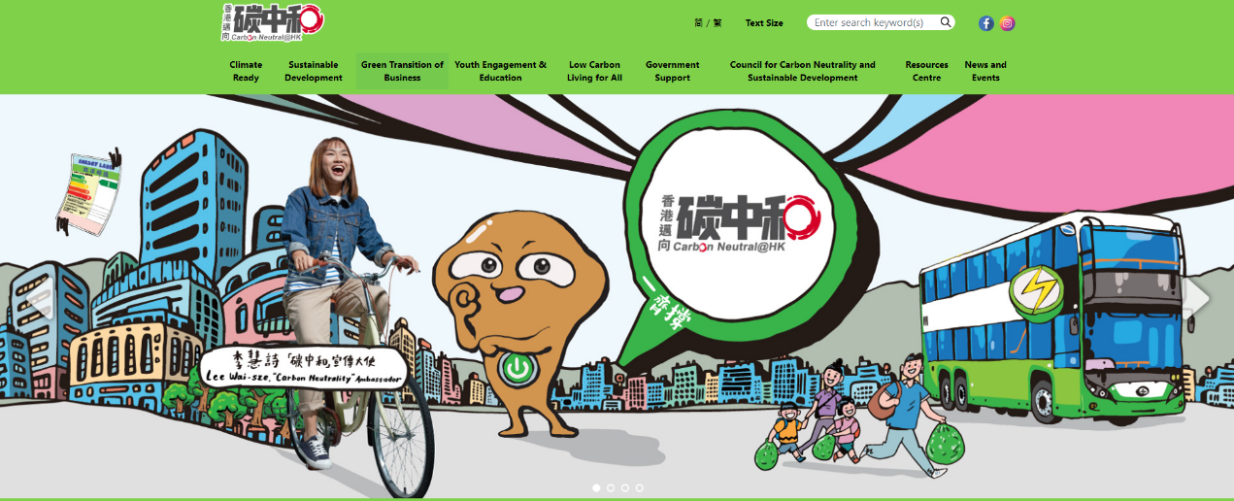

Environmental and Ecology Bureau Website
https://cnsd.gov.hk/en/

References
Investor and Financial Education Council Website
https://www.ifec.org.hk

Tetra Pak (2018). Tetra Pak plant-based carton using bio-based plastic made from sugarcane (Chinese subtitles)
https://www.youtube.com/watch?v=KY3BRs3DGYs&feature=emb_logo

Consumer Council
https://www.consumer.org.hk/

Hong Kong Economic Journal Company Limited. “Handy Finance” website.
http://iknow.hkej.com/financeinfographics/

The Green Earth.
https://greenearth.org.hk/2016/02/20160227/

The Conservancy Association.
https://www.cahk.org.hk/?gclid=Cj0KCQjwpfHzBRCiARIsAHHzyZoh5uS4eF7rnQprLx6CUxLBJRUrZ8koVDBKrSDt9-Vooxy0hwBtJRAaAhMAEALw_wcB&lang=en

Singtao Daily (2007).《消費洪流氾濫 簡樸生活知足尺度》。

Intellectual Property Department, the Government of the Hong Kong Special Administrative Region.
https://www.ipd.gov.hk/eng/home.htm

Intellectual Property Department, the Government of the Hong Kong Special Administrative Region. Survey on Public Awareness of Intellectual Property Right Protection 2018.
https://www.ipd.gov.hk/eng/promotion_edu/survey/ipr_report_pub_2018.pdf

Intellectual Property Department, the Government of the Hong Kong Special Administrative Region. Comics on Intellectual Property.
https://www.ipd.gov.hk/eng/promotion_edu/educational_corner/comics/index.htm

Education Bureau, the Government of the Hong Kong Special Administrative Region. “Promotion of Sustainable Development Education in Hong Kong” Learning Material Kit. (Chinese version only)
https://www.edb.gov.hk/tc/curriculum-development/4-key-tasks/moral-civic/newwebsite/flash/esd/experience.html

Education Bureau, the Government of the Hong Kong Special Administrative Region. Junior Secondary Financial Education Learning and Teaching Resources.
https://www.edb.gov.hk/en/curriculum-development/kla/pshe/references-and-resources/cross-curricular-resources/financial-education.html

Education Bureau, the Government of the Hong Kong Special Administrative Region (2018). “On Economic Concepts: GDP, Unemployment and Inflation”, ETV Resources.
https://www.hkedcity.net/etv/resource/2028167627

Education Bureau, the Government of the Hong Kong Special Administrative Region (2019). “Personal Resource Management: Managing Finance”. “3-minute Concept” Animated Video Clips Series (2019).
https://www.edb.gov.hk/en/curriculum-development/kla/pshe/references-and-resources/life-and-society/3-min-concept.html

GovHK, the Government of the Hong Kong Special Administrative Region (2020). Intellectual Property Protection.
https://www.gov.hk/en/residents/communication/infosec/intproperty.htm

Press release, the Government of the Hong Kong Special Administrative Region (11 February 2019). Awareness of intellectual property rights protection remains high.
https://www.info.gov.hk/gia/general/201902/11/P2019021100544.htm

Environmental and Ecology Bureau, the Government of the Hong Kong Special Administrative Region.
https://www.eeb.gov.hk/en/top.html

Environmental and Ecology Bureau, the Government of the Hong Kong Special Administrative Region. Low Carbon Living Calculator.
https://www.carboncalculator.gov.hk/en

“Carbon Neutral@ HK”, Environmental and Ecology Bureau, the Government of the Hong Kong Special Administrative Region. Carbon Emissions and Hong Kong.
https://cnsd.gov.hk/en/video/

The Hong Kong Police Force, the Government of the Hong Kong Special Administrative Region.
https://www.police.gov.hk/ppp_en/04_crime_matters/ccb/fst.php?msg_id=cct_28

The Hong Kong Police Force the Government of the Hong Kong Special Administrative Region. Anti-Deception Coordination Centre website.
https://www.adcc.gov.hk/en-hk/home.html

Creative Commons Hong Kong website.
https://hk.creativecommons.org/faq

Michelin Guide, Hong Kong
https://guide.michelin.com/hk/en/hong-kong-region/hong-kong

Hong Kong Economic Times (6 June 2020).《【大慈善家】退休老師捐4.6億身家回饋社會 女兒：阿爺很節儉才剩下這麼多給子孫》。
https://topick.hket.com/article/2663469/【大慈善家】退休老師捐4.6億身家回饋社會%20%20%20%20女兒：阿爺很節儉才剩下這麼多給子孫

Yahoo! Finance.
https://hk.finance.yahoo.com/

Cyber Security Information Portal.
https://www.cybersecurity.hk/en/index.php

Cyber Security Information Portal. Security Considerations on Electronic Transactions (I).
https://www.youtube.com/watch?v=aUwsIXvnjJQ

Cyber Security Information Portal. Security Considerations on Electronic Transactions (II).
https://www.youtube.com/watch?v=PKyJcW4QN8Y

Student Finance Office. Tertiary Student Finance Scheme - Publicly-funded Programmes (TSFS) Overview, downloaded on 20 April 2020.
https://www.wfsfaa.gov.hk/sfo/en/postsecondary/tsfs/overview.htm



